Mech-a-Blocks

Teacher’s Guide

Overview
Mech-a-Blocks introduces mechanical concepts to young children. They learn about structures and mechanisms, inputs and outputs, levers, direction and amount of motion. They learn through the mechanical devices they designs and build. “Mech-a-Blocks” are reconfigurable mechanical building blocks. Unlike ordinary blocks (which are designed for making structures), children can use Mech-a-Blocks to create mechanisms as well as structures.
Common Core Writing Standards K-1

Text Types and purposes

2. Use a combination of drawing, dictating and writing to compose informative/ explanatory texts (K); Write informative/explanatory texts (1).

Production and Distribution of writing

5. With guidance and support from adults, respond to questions questions and suggestions from peers and add details to strengthen writing as needed.

Research to Build and Present Knowledge

8. With guidance and support from adults, recall information from experiences to answer a question.

Common Core Speaking and Listening Standards K-1

Comprehension and Collaboration

1. Participate in collaborative conversations with diverse partners.

Presentation of Knowledge and Ideas

4. Describe familiar events

5. Add drawings to descriptions to provide additional detail.

Common Core Language Standards K-1

Conventions of Standard English

1. Demonstrate command of the conventions of standard English grammar and usage when writing or speaking.

Vocabulary acquisition and use

4. Demonstrate or clarify the meaning of unknown and multiple-meaning words and phrases.

Common Core Learning Standards for Mathematics
Standards for Mathematical Practice
MP 4: Model with mathematics.
MP 5: Use appropriate tools strategically.
MP 6: Attend to precision.
Measurement and Data (K.MD)
Describe and compare measurable attributes.
1. Describe measurable attributes of objects, such as length or weight.
Describe several measurable attributes of a single object.
2. Directly compare two objects with a measurable attribute in common, to see which object has “more of”/“less of” the attribute, and describe the difference.
Measurement and Data (1.MD)
Measure lengths indirectly and by iterating length units.
1. Order three objects by length; compare the lengths of two objects indirectly by using a third object.
2. Express the length of an object as a whole number of length units, by laying multiple copies of a shorter object (the length unit) end to end; understand that the length measurement of an object is the number of same-size length units that span it with no gaps or overlaps.
Represent and interpret data.
4. Organize, represent, and interpret data with up to three categories; ask and answer questions about the total number of data points, how many in each category, and how many more or less are in one category than in another.
Geometry (K.G)
Identify and describe shapes
1. Describe objects in the environment using the names of shapes
2. Correctly name shapes regardless of their orientations or overall size
Analyze, create, compare and compose shapes
4. Analyze and compare two- and three-0dimensional shapes
5. Model shapes in the world by building shapes from components
6. Compose simple shapes to form larger shapes
Geometry (1.G)
Reason with shapes and their attributes
2. Compose two-dimensional shapes to create a composite shape

Next Generation Science Standards/ Frameworks for K-12 Science Education
Dimension 1: Scientific and Engineering Practices:
- Asking questions and defining problems: Students should be able to ask questions of each other about the phenomena they observe and the conclusions they draw from their models or scientific investigations. For engineering, they should ask questions to define the problem to be solved and to elicit ideas that lead to the constraints and specifications for its solution.
- Developing and using models: Students should be asked to use diagrams, maps and other abstract models to as tools that enable them to elaborate on their own ideas, develop explanations and present them to others.
- Planning and carrying out investigations: In the elementary years, students’ experiences should be structured to help them learn to define the features to be investigated, such as patterns that suggest causal relationships.
- Analyzing and interpreting data: At the elementary level, students need support to recognize the need to record observations – whether in drawings, words or numbers – and to share them with others.
- Using mathematics and computational thinking: Students should have opportunities to explore how symbolic representations can be used to represent data and to predict outcomes.
- Constructing explanations and designing solutions: The process of developing a design is iterative and systematic, as is the process of developing an explanation in science. Elements that are distinctive in engineering include specifying constraints and criteria for desired qualities of the solution, developing a design plan, producing or testing models or prototypes, selecting among alternative design features, and refining design ideas based on the performance of a prototype.
- Engaging in argument from evidence: In engineering, reasoning and argument are essential to finding the best possible solution to a problem. At an early design stage, competing ideas must be compared (and possibly combined), and the choices are made through argumentation about the merits of the various ideas pertinent to the design goals.
- Obtaining, evaluating and communicating information: In engineering, Students need opportunities to communicate ideas using appropriate combinations of sketches, models and language. They should also create drawings to test concepts and communicate detailed plans; explain and critique models, and present both planning stages and ultimate solutions.
Dimension 2: Crosscutting concepts:
- Patterns: Noticing patterns is often a first step to organizing and asking scientific questions about why and how the patterns occur. In engineering, it is important to observe and analyze patterns of failure in order to improve a design.
- Cause and effect: mechanism and prediction: Any application of science, or any engineered solution to a problem, is dependent on understanding the cause-and-effect relationships between events. The process of design is a good place to start, because students must understand the underlying causal relationships in order to devise and explain a design to achieve a specified objective.
- Scale, proportion and quantity: The concept of scale builds from the early grades as an essential element of understanding phenomena. Young children can begin understanding scale with objects, space and time related to their world and with scale models and maps.
- Systems and system models: A system is an organized group of related objects or components that form a whole. Models can be valuable in predicting a system’s behaviors or in diagnosing its problems and failures. Starting in the earliest grades, students should be asked to express their thinking with drawings or diagrams and with written or oral descriptions. They should describe objects in terms of their parts and the role those parts play in the functioning of the object.
- Energy and matter: flows cycles and conservation: Laws of conservation of matter and energy provide limits on what can occur in a system, whether human-built or natural. The ability to examine, characterize and model the transfers and cycles of matter and energy is a tool that students can use across virtually all areas of science and engineering.
- Structure and function: The functioning of systems depends on the shapes and relationships of certain key parts, as well as on the properties of the materials. Exploration of the relationship between structure and function can begin in the early grades through investigations of accessible systems in the natural and human-built world.
- Stability and change: Much of science and mathematics has to do with understanding how change occurs in nature and in social and technological systems, and much of engineering has to do with creating and controlling change.
Dimension 3: Disciplinary Core Ideas – Physical Science:
Core Idea PS2: Motion and Stability: Forces and Interactions
Interactions between any two objects can cause changes in one or both of them. An understanding of the forces between objects is important for describing how their motions change, as well as for predicting stability or instability in systems.
Dimension 3: Disciplinary Core Ideas – Engineering, Technology and Applications of Science
Core Idea ETS1: Engineering Design
Engineering design begins with the identification of a problem and the specification of clear goals that the final product or system must meet, while contending with a variety of limitation, or constraints, that place restrictions on a design. Models allow the designer to better understand the features of a design problem, visualize elements of a possible solution and predict a design/s performance. Because there is always more than one possible solution to a problem, it is useful to compare designs, test them and compare their strengths and weaknesses. Selection of a design often requires making trade-offs among competing criteria.
Core Idea ETS2: Links among Engineering, Technology and Society
Advances in science, engineering and technology have had profound effects on human society, which can change significantly when new technologies are introduced, with both desired effects and unexpected outcomes.

Curriculum Map
Lesson | Title | Summary | Approx. time (min.) | Vocabulary | Assessment Methods
1 | What can you make? | Explore Mech-a-blocks, make things from then learn how to use them | 100 | base, fastener, pivot, strip, shape | Observation, discussion, written work
2 | Structures and Mechanisms | Identify the differences between structures and mechanisms | 50 | cause-and-effect, fixed fastener, fixed pivot, floating pivot, input, mechanism, output, phony fastener, structure, system, | Observation, discussion, written work, student projects
3 | A Mechanism with an Input that Controls it | Create inputs that control outputs | 100 | control, fixed pivot, floating pivot, input controlling lever, lever | Observation, discussion, written work, student projects
4 | Mechanism Diagrams | Develop diagrams that can be used as blueprints for building | 100 | diagram, drawing, symbol | Drawings and diagrams made by students
5 | Modeling Mechanisms | Build models of mechanisms in cardstock | 100 | cardstock, model, pegboard | Observation, student projects
6 | Modeling Manufactured Mechanisms | Make mechanisms in Mech-a-blocks or cardstock based on real everyday mechanisms | 50 |  | Observation, discussion, written work
7 | Which way will it go? | Explore movements associated with see-saws | 50 | Direction, same, opposite | Observation, discussion, written work
8 | How to Get a Better Ride | Exploring how changes in the location of a fulcrum effect amount of movement | 50 | circumference, center, output arm, output circle, output path, proportion, radius | Observation, discussion, written work
9 | Catching the Butterfly | Introduction to MechAnimations, using Mech-a-blocks to tell stories | 50 |  | Observation, discussion, written work
10 | Make your Own! | Students make their own MechAnimations | 150 |  | Observation, student projects

Lesson | Title | Standards alignment
 |  | CCLS -- ELA | CCLS -- Math | NGSS -- Science & Engineering Practices | NGSS -- Cross-cutting Concepts | Disciplinary Core Ideas
1 | What can you make? | Writing: Text types and purposes; Production and distribution of writing  Speaking and Listening: Presentation of knowledge and ideas  Language: Vocabulary acquisition and use | Standards for Mathematical Practice:  MP 4: Model with mathematics  Measurement and Data (K.MD & 1. MD)  Geometry (K.G & 1.G) | 3. Planning and carrying out investigations  8. Obtaining, evaluating and communicating information | 2. Cause and effect: mechanism and prediction  3. Scale, proportion and quantity | ETS1: Engineering Design
2 | Structures and Mechanisms | Writing: Text types and purposes; Production and distribution of writing  Speaking and Listening: Comprehension and collaboration; Presentation of knowledge and ideas  Language: Vocabulary acquisition and use | Standards for Mathematical Practice:  MP 4: Model with mathematics  Measurement and Data (K.MD & 1. MD)  Geometry (K.G & 1.G) | 1. Asking questions and defining problems  3. Planning and carrying out investigations  8. Obtaining, evaluating and communicating information | 2. Cause and effect: mechanism and prediction  4. Systems and system models  6. Structure and function  7. Stability and change | PS2: Motion and Stability: forces and interactions  ETS1: Engineering Design
3 | A Mechanism with an Input that Controls it | Writing: Text types and purposes; Production and distribution of writing  Speaking and Listening: Presentation of knowledge and ideas  Language: Vocabulary acquisition and use |  | 1. Asking questions and defining problems  3. Planning and carrying out investigations  8. Obtaining, evaluating and communicating information | 1. Patterns  2. Cause and effect: mechanism and prediction  5. Energy and matter: flows cycles and conservation  6. Structure and function  7. Stability and change | PS2: Motion and Stability: forces and interactions  ETS1: Engineering Design
4 | Mechanism Diagrams | Writing: Text types and purposes; Production and distribution of writing  Speaking and Listening: Presentation of knowledge and ideas  Language: Vocabulary acquisition and use | Measurement and Data (K.MD & (1.MD)  Geometry (K.G & 1.G) | 2. Developing and using models  5. Using mathematics and computational thinking  8. Obtaining, evaluating and communicating information | 3. Scale, proportion and quantity  4. Systems and system models  6. Structure and function

Lesson | Title | Standards alignment
 |  | CCLS -- ELA | CCLS -- Math | NGSS -- Science & Engineering Practices | NGSS -- Cross-cutting Concepts | Disciplinary Core Ideas
5 | Modeling Mechanisms | Speaking and Listening: Comprehension and collaboration; Presentation of knowledge and ideas  Language: Vocabulary acquisition and use | Standards for Mathematical Practice: MP 4: Model with mathematics;  MP 5: Use appropriate tools strategically;  MP 6: Attend to precision  Measurement and Data  (K.MD & 1.MD)  Geometry (K.G & 1.G) | 2. Developing and using models  5. Using mathematics and computational thinking  8. Obtaining, evaluating and communicating information | 3. Scale, proportion and quantity  4. Systems and system models  6. Structure and function | PS2: Motion and Stability: forces and interactions  ETS1: Engineering Design
6 | Modeling Manufactured Mechanisms | Speaking and Listening: Comprehension and collaboration; Presentation of knowledge and ideas  Language: Vocabulary acquisition and use | Standards for Mathematical Practice:  MP 4: Model with mathematics  Measurement and Data (K.MD & 1. MD)  Geometry (K.G & 1.G) | 1. Asking questions and defining problems  6. Constructing explanations and designing solutions | 1. Patterns  2. Cause and effect: mechanism and prediction  4. Systems and system models  5. Energy and matter: flows cycles and conservation  6. Structure and function  7. Stability and change | PS2: Motion and Stability: forces and interactions  ETS1: Engineering Design  ETS2: Links among Engineering, Technology and Society
7 | Which way will it go? | Speaking and Listening: Comprehension and collaboration; Presentation of knowledge and ideas  Language: Vocabulary acquisition and use | Measurement and Data (K.MD & 1. MD) | 2. Developing and using models  3. Planning and carrying out investigations  4. Analyzing and interpreting data  8. Obtaining, evaluating and communicating information | 1. Patterns  2. Cause and effect: mechanism and prediction  4. Systems and system models  6. Structure and function  7. Stability and change | PS2: Motion and Stability: forces and interactions  ETS1: Engineering Design

Lesson | Title | Standards alignment
 |  | CCLS -- ELA | CCLS -- Math | NGSS -- Science & Engineering Practices | NGSS -- Cross-cutting Concepts | Disciplinary Core Ideas
8 | How to Get a Better Ride | Speaking and Listening: Comprehension and collaboration; Presentation of knowledge and ideas  Language: Vocabulary acquisition and use | Standards for Mathematical Practice:  MP 4: Model with mathematics  Measurement and Data (K.MD & 1. MD)  Geometry (K.G & 1.G) | 1. Asking questions and defining problems  3. Planning and carrying out investigations  4. Analyzing and interpreting data  5. Using mathematics and computational thinking  6. Constructing explanations and designing solutions  7. Engaging in argument from evidence | 1. Patterns  2. Cause and effect: mechanism and prediction  4. Systems and system models  5. Energy and matter: flows cycles and conservation  6. Structure and function  7. Stability and change | PS3: Energy  Information Transfer  ETS1: Engineering Design
9 | Catching the Butterfly | Speaking and Listening: Presentation of knowledge and ideas  Language: Vocabulary acquisition and use |  | 2. Developing and using models | 2. Cause and effect: mechanism and prediction  4. Systems and system models  5. Energy and matter: flows cycles and conservation  6. Structure and function  7. Stability and change | PS2: Motion and Stability: forces and interactions  ETS1: Engineering Design
10 | Make your Own! | Writing: Text types and purposes; Production and distribution of writing  Speaking and Listening: Comprehension and collaboration; Presentation of knowledge and ideas  Language: Vocabulary acquisition and use |  | 1. Asking questions and defining problems  3. Planning and carrying out investigations  6. Constructing explanations and designing solutions  8. Obtaining, evaluating and communicating information | 2. Cause and effect: mechanism and prediction  4. Systems and system models  5. Energy and matter: flows cycles and conservation  6. Structure and function  7. Stability and change | PS2: Motion and Stability: forces and interactions  ETS1: Engineering Design

Teaching Strategies
Learning: People learn by doing, and then reflecting on what they have done. In engineering, the goal is to design and create something new, and new designs rarely work well the first time. The effort to troubleshoot and fix something that doesn’t work provides rich motivation for learning. This curriculum unit provides numerous opportunities for students to explore for themselves, make things based on what they have learned, and reflect on their work in both oral and written form. Just as there is no one way to design something new, there is no one way to teach this unit. Be creative and flexible, and your students will be too!
Vocabulary: Words are not very meaningful unless they are connected with concepts. For this reason, we do not believe in presenting vocabulary words at the beginning of a lesson. Provide students with experiences that allow them to develop the concepts for themselves, and encourage them to use their own words to describe these concepts. Then provide the words that professional scientists and engineers use to describe these same concepts. These are the words provided in the Vocabulary column of the curriculum maps and the Word Bank section of each lesson. The Glossary at the end of this unit provides a working definition for each word.
Writing and Drawing: Writing and drawing are essential parts of engineering design. The person who created something new is the only person who can describe what they did, and may be strongly motivated to convey these original ideas to others. This curriculum unit provides numerous opportunities for students to make sense of what they have done through text and graphics. They are encouraged to describe what they plan to make, the issues that prevented it from working, and how someone else could make it, how it works and what was learned from it.
As much as possible, students need to express themselves in their own words (see Vocabulary, above), with no more prompts than necessary to get them started. The boxes labeled Science Notebook and the worksheets in the lessons provide starting points. These can be used in any combination, and students should also have opportunities to do more open-ended writing, for example to reflect on how they feel about their work.
Science Notebook entries are boxed.
- Writing prompts have lightning bullets.
Writing in notebooks and worksheets is primarily for the students themselves – to help them consolidate and remember what they have learned and communicate it to others – but it also serves as an assessment tool. It should not be marked closely for grammar and spelling. However, it is appropriate to ask students to read what they have written to the class, and to challenge them to clarify ideas that are unclear or incomplete. Much of the description will require drawings or diagrams as well as text, and it is important to help students learn to coordinate these two modes of communication.
Discussion: Speaking and listening are essential forms of literacy and are central to learning science and engineering. The purpose of a discussion, like that of writing and drawing, is to create meaning. A discussion is not a question-and-answer session led by the teacher, nor a sharing session in which students simply report on what they did. Making meaning requires that students listen and respond to one another’s ideas. In a discussion of engineering design, students may want to bring up issues that they have encountered. Other students may respond by identifying similar issues, and/or by suggesting solutions that they have come up with. As the teacher, your role is to facilitate this give-and-take, by posing questions for discussion and then maintaining focus within the group. Sample focusing questions are identified like this within each lesson:
- Lightning bullets and italics indicate prompts for discussion
Reference: Worth, K., Winokur, J. Crissman, S., Heller-Winokur, M. (2009) The Essentials of Science and Literacy: A Guide for Teachers. Portsmouth, NH: Heinemann.
Structure of the Lesson Plans
The following categories appear in each lesson (*), or most lessons (**):
*Essential Question
*Task
*Standards
*Outcomes
*Assessment
**Advance Preparation
*Materials
*Procedure
**Word bank
**Worksheets

Overview of Basic concepts
Mechanism: Students may notice that one part of a construction can jiggle a little while the base is still, and ask whether it counts as a “moving part.” Our answer is “no.” There is usually a little bit of play between the parts, due to the paper fasteners not fitting tightly in the holes of the pegboard. If a part can move only slightly, we still consider it a structure. A mechanism has to be able to rotate all or most of the way around a pivot.
Structures: In a mechanism, each part is attached to the base by at most one fixed fastener. A structure generally uses more than one. Figure 1 of Lesson 1 (houses) is a structure, while Figure 2 of Lesson 1 (four-legged creature) is a mechanism. You can always turn a structure into a mechanism by removing fixed pivots, or go from a mechanism to a structure by adding them.
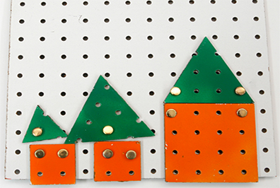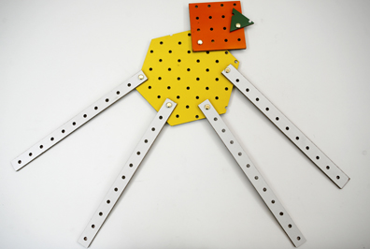
Figure 1: Sample Mech-a-Blocks constructions: Houses (left); Four-legged creature (right)
Mechanism versus Structure: Any device that has moving parts is a mechanism. If something has no moving parts, it is called a structure. A structure can move only as a unit – all the parts have to travel together. A desk, chair, box, board or stick is a structure, either because it has only one part, or because none of its parts is supposed to move independently of the other parts. A pair of scissors, stapler, tweezers, door lock or skateboard each has moving parts, so it is a mechanism. The following saying was circulating on-line:
There are only two tools you’ll ever need: Duct Tape and WD-40™. Here’s how you’ll know which one to use: if it moves and it shouldn’t move, use duct tape if the opposite is true, use WD-40™.
In our terminology, Duct Tape converts a mechanism into a structure, while, WD-40™ changes a structure into a mechanism! Common mechanisms are listed in Table 1.
Parts of a Mechanism: The simplest mechanism consists of one part that can rotate around another, like a pinwheel or an arm represented by a stick. This kind of mechanism consists of three basic parts: a base, the part that doesn’t move; a wheel or lever that does move around the base, and a fastener, which holds the lever in place, allowing it to turn but not slide. The base and lever can be any shape – not necessarily rectangular. The fastener – also called a pin or a pivot -- makes the connection to the base that allows turning but not sliding to and fro. Another property of a lever is that you normally push it or pull it at one point, the input, to cause a related movement you want at another point, the output. For example, when you use a pair of scissors, you squeeze the handles to make the blades move. The part you squeeze is the input, and the part that cuts is the output, and both can turn around a pivot (see Figure 2). Learning to identify inputs and outputs is a first step in developing notions of cause, effect and system.

Type | Examples
Toys | pull toy, wind-up, robot, car, keyboard
Outdoor play | See-saw, carousel, scooter, skateboard, tricycle, tricycle bell
School supplies | scissors, glue stick, stapler, hole punch, folder, ball-point pen
Kitchen utensils | clip for sealing snack bags, can opener, salad and barbecue tongs, nutcracker, chopsticks for kids, ice cream scoop
Human body | Arms, legs, jaw, fingers, toes, head
Health & beauty | nail clippers, eyelash curler, pump dispenser, tweezers, hair clip
Home | Pedal-operated wastebasket, light switch, desk lamp, ironing board, folding mirror, folding chair, folding ladder, shopping cart, umbrella, door, door lock, mouse trap, faucet
Construction site | garbage truck, crane, front loader, backhoe, hoist
Table 1: Familiar Mechanisms
Figure 2: Scissors as pair of levers
Fasteners: The three uses of fasteners are critical to determining whether something will be a structure or a mechanism. A phony fastener has no mechanical purpose. It just becomes part of the structure it is attached to. A floating fastener – because it can move independent of the base – is part of a mechanism. A fixed fastener could either be part of a mechanism – holding it together, and allowing one part to rotate – or part of a structure.

Teacher Notes on the Lessons
Lesson 2: Structures and Mechanisms
The key to making something a structure or a mechanism is the number of fixed fasteners:
- If a piece is attached to the base with one fixed fastener, it will be able to rotate, and therefore be a mechanism attached to the base. See Figure 1. In this case, another word for the fastener would be a pivot, because it allows something to rotate.
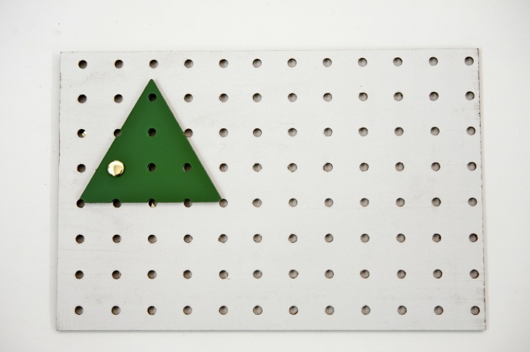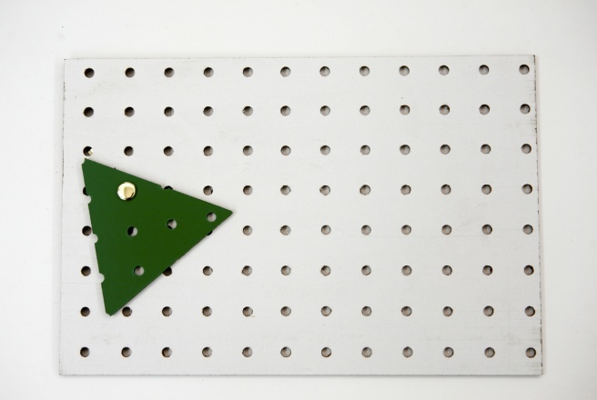
Figure 1: A mechanism made with two pieces and a fastener
- If a piece is attached to the base by two or more fixed fasteners, it will not be able to move separately, and therefore be part of a structure with the base, as in Figure 2.
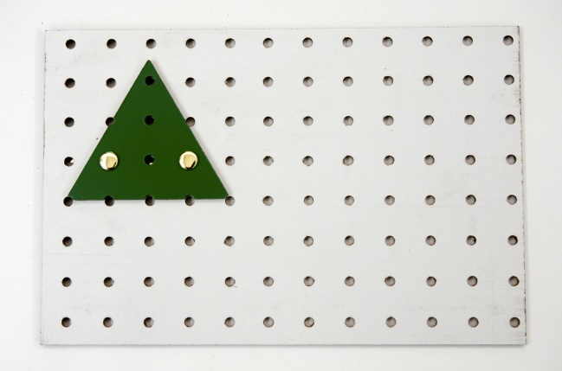
Figure 2: Adding a fastener turns a mechanism into a structure

Lesson 3: A Mechanism with an Input that Controls it
An obvious way to attempt the design challenge would be simply to push the trapezoid with a strip, as shown in Figure 1. First, you see the lever with no separate input. Then a strip is lined up with the trapezoid, and used to push the trapezoid to the right. However, this method does not satisfy the goal of controlling the trapezoid, because when the strip is pulled back to the left, the trapezoid does not follow it.
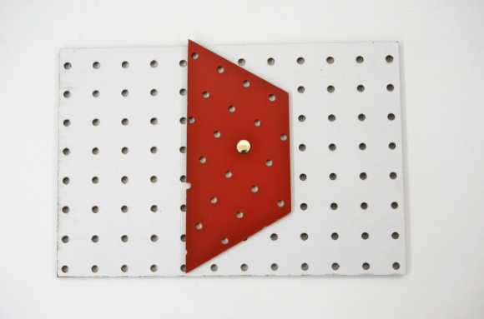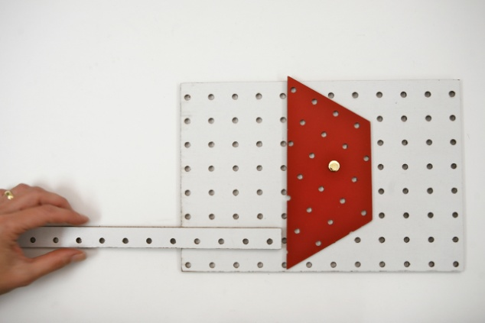
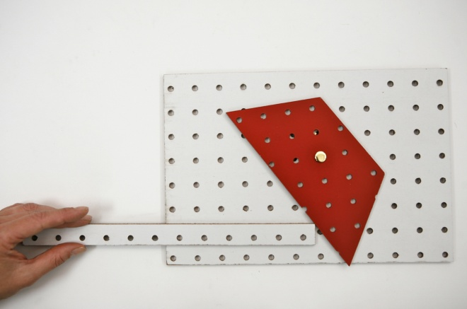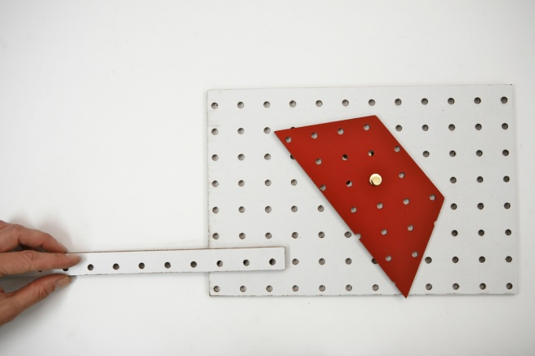
Figure 1: The strip does not control the trapezoid. It can push it to the right, but not pull it back to the left
In order for an input (the strip) to control a lever (the trapezoid), it needs to be attached to it somehow. Another idea would be to put a fastener through the strip, the trapezoid and the base, as shown in Figure 2.
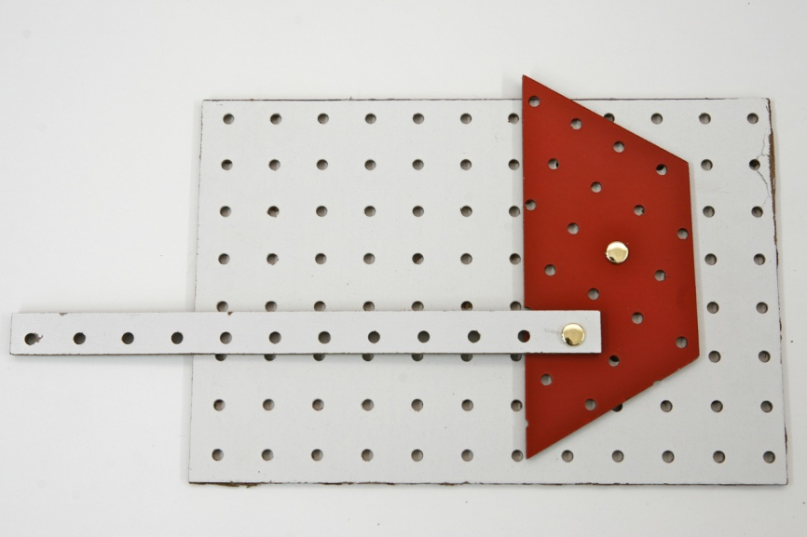
Figure 2: Second (failed) attempt to make Y control X
This second method is even worse than the first, because now the trapezoid can't move at all! Why not? As the Teacher Notes for Lesson 2 shows, putting two fasteners through a strip and the base makes the strip and the base into a structure. That is exactly what has now happened to the trapezoid.
The solution is to use a fastener that connects the strip and trapezoid to each other, but not to the base. As shown in Figure 2, the strip is first attached to the trapezoid with a fastener. Then the trapezoid is attached to the base with a fixed pivot, as shown in Figure 3. Notice that the legs of the fastener are pointing up. This will make it easier for the floating pivot to slide over the base.
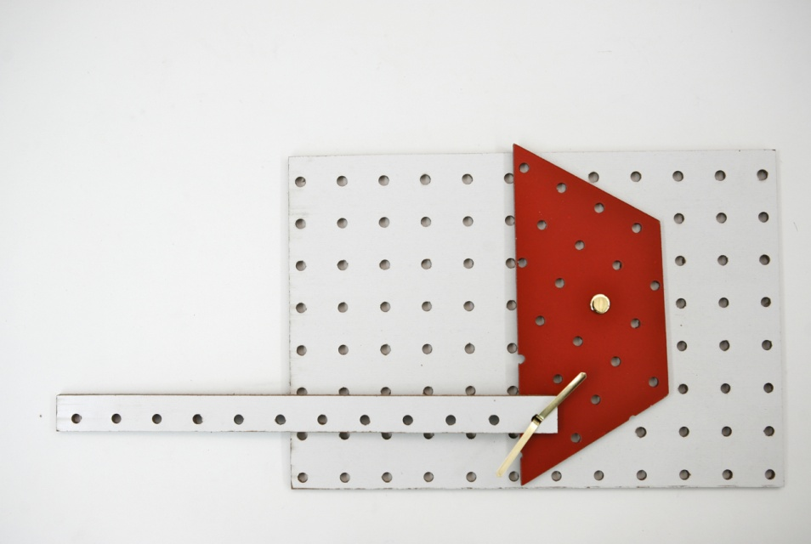

Figure 3: A mechanism that has an input strip controlling it
The result is a mechanism that meets the challenge, as shown in Figure 4. Pulling the strip to the left rotates the trapezoid clockwise (left), while pushing the strip to the right rotates the trapezoid counterclockwise (right).
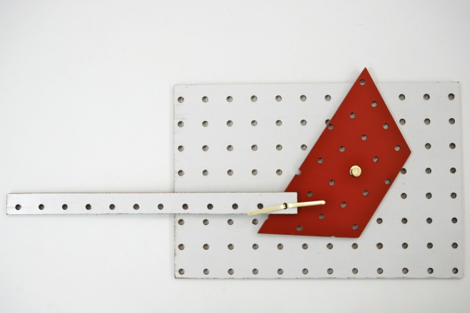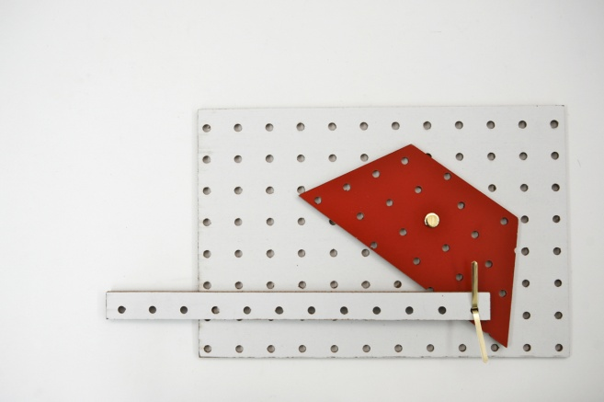
Figure 4: Strip Y now controls strip X

Lesson 4: Mechanism Diagrams
Figure 1 shows convenient symbols that make it easy to distinguish between fixed and floating pivots:
Figure 1: Handy symbols for both kinds of pivots
Figure 2 shows an example of how these symbols can be used, by providing a diagram of the mechanism shown in Figure 4, Lesson 3 Teacher Notes:
Figure 2: Diagram of trapezoid with input control
Lesson 5: Modeling Mechanisms
An easy way to align the holes in the cardstock with the original pegboard holes is to lay the pegboard piece over the cardstock piece, and trace the holes location with a pencil. See Figure 1.
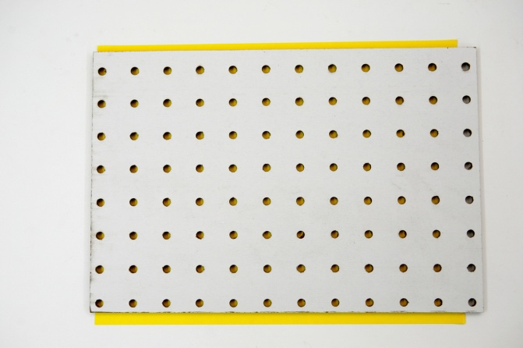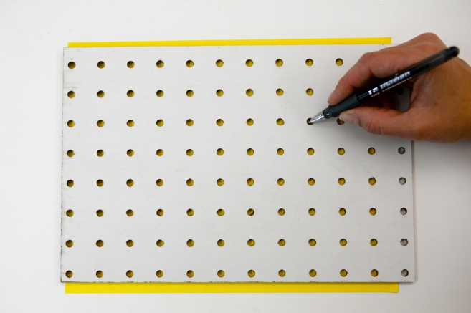
Figure 1: Using pegboard above cardstock, to mark the hole location on cardstock
Once you have marked a hole location, here is a procedure for punching the hole, so you can put a fastener through it:
- Place a piece of cardstock on top of a soft surface, such as a rug or a thick piece of cardboard. Alternatively, you can put the cardstock over a piece of pegboard, making sure the mark is right over a hole in the pegboard.
- Push the pencil point through the cardstock to make a small hole. The soft surface or pegboard hole should allow the pencil to go through. See Figure 2
- Remove the cardstock from the soft surface or pegboard, and push a fastener through the hole you just made.
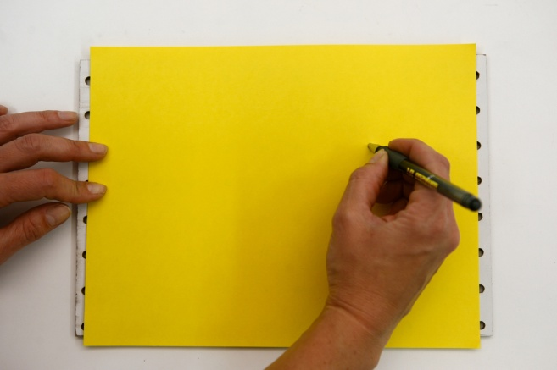
Figure 2: Using pegboard below cardstock, to punch holes in cardstock

The differences between cardstock and pegboard can be summarized as in Table 1.

Issue | Pegboard | Cardstock
holes | has them | has none
stiffness | Stiff – won’t bend | Flexible – bends a lot
cost | Expensive – can’t take it home | Cheap – you can use a lot of it
Table 1: Comparing materials
Table 2 shows some examples of models, which could arise from the discussion about modeling in general.
Original | Model | Similarities | Differences
Real car | toy car | Made of metal, both can roll | Real Car is bigger, goes by itself
Real house | doll house | Doors and windows | Real house is bigger, has lights and water
Real animal | Stuffed animal | Look similar | Different materials, real animal is alive
Doll | person | Look similar | Different sizes and materials, real person is alive and usually bigger
Pegboard mechanism | Cardstock mechanism | Inputs and outputs move the same way | Pegboard is stronger, harder to bend
Table 2: Comparing the model and the real thing

Lesson 8: How to Get a Better Ride
Students may have difficulty seeing how the location of the fixed pivot affects the distance traveled. If so, you might set up the seesaw, as in Figure 1 a) and then move the fixed pivot to different a hole each time, to see the effect on the movements of both cat and mouse. See Figures 1 b) and c).

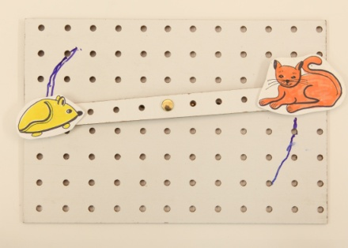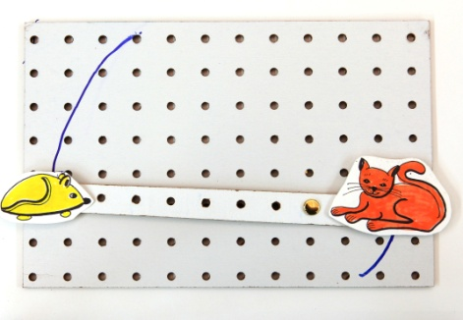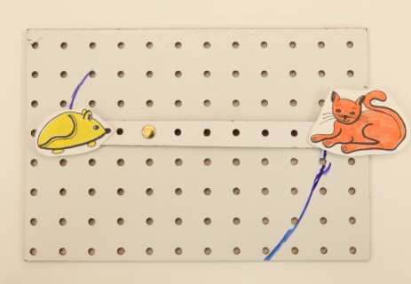
a) Original location b) Pivot moved to the right c) Pivot moved to the left
Figure 6: Changing the fixed pivot location to see the effect on movement of cat & mouse
In Figure 1a), the pivot is in the center, and the cat and mouse move about equally. In b), the pivot has been moved to the right, and the mouse moves more. In c), the pivot is towards the left, giving the cat a better d.
In this lesson, students examine the path traveled by a lever, which is an example of a locus of points. Because the fixed pivot forces the lever to rotate, the output path must be part of a circle, whose center is at the fixed pivot – in other words, an arc. The central question in the lesson is:
What controls the length of the output path?
In Figure 1a0 both paths are about the same length, but in 1 b), the mouse moves further than the cat. In 1 c), the opposite is true. Why?
Figure 2shows the paths the outputs of two levers follow if you trace them all the way around.

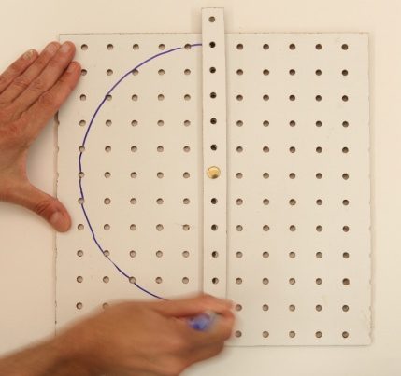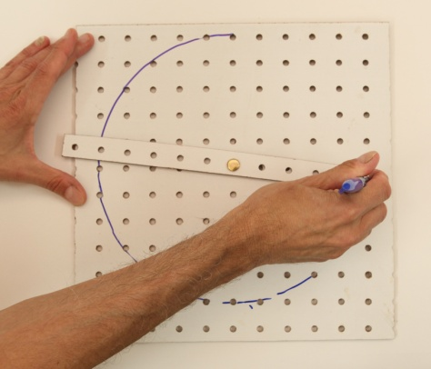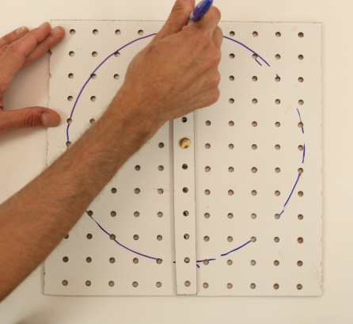
a) A circle drawn using a hole that is far from the fixed pivot

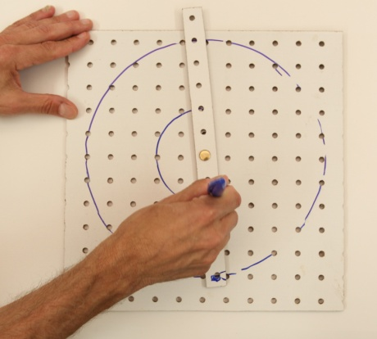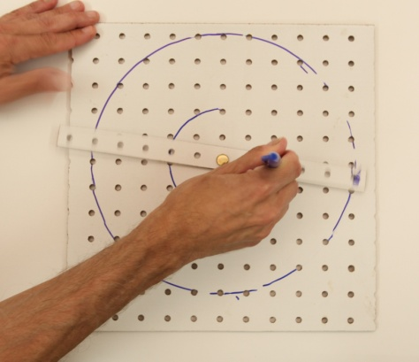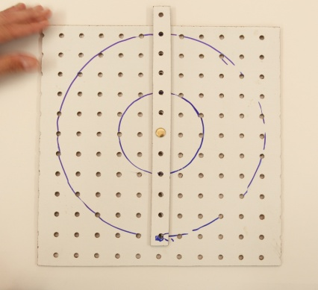
b) A second circle drawn using a different hole c) Comparing the two circles
Figure 2: Using a strip of pegboard as a compass, and then comparing circle sizes
What makes one of these paths longer than the other? Just that it is further from the fixed pivot. The distance of an output from the fixed pivot is called the radius or output arm. The distance around a full circle is called the circumference. If the output doesn’t complete a full circle, it travels in an arc, which is just part of a circle. The path the output travels is then called the arc length. See Figure 3.
Figure 8: Circle relationships
Suppose there are two outputs that both rotate on the same lever, as in Figure 3. Since they are on the same lever, they have to rotate through the same angle, or fraction of a full circle. The one with the longer radius will travel the furthest. Figure 4 shows two output paths that have the same angle.
Figure 4: Comparing arc lengths and arm lengths

Lesson 9: Catching the Butterfly
This lesson gets at the difference in directions of motion between first and third-class levers. In the language of levers, a fixed pivot is called a fulcrum. Figure 1 reveals the at the heart of the Happy Butterfly Net mechanism. Because the fulcrum is in between input and output, they have to go in opposite directions, just like in a scissors or see-saw. See also Teacher Notes for Lesson 7.

Figure 1: Input and output go in opposite directions, when the fulcrum is between them
Figure 2 is a similar diagram showing how the Unhappy Butterfly Net mechanism works. Here, the input is at one end, and the fulcrum is at the other. Because the input and output are on the same side of fulcrum, they have to move in the same direction, like in a tweezers or salad tongs.

Figure 3: Input and output travel in the same direction, when the fulcrum is at one end

Materials
The materials needed for the Mech-a-Blocks curriculum consist of:
- A classroom set of Mech-a-Blocks, including pegboard and cardstock shapes and brass paper fasteners (brads) – See Figure 1 & Table 1, below.
- Templates for making cut-out figures (see Table 2).
- Some manufactured mechanisms. These could include salad tongs, nut crackers, pliers, scissors, etc. The materials kit includes two large mechanisms: a pair of fireplace tongs, and a set of expandable wooden coat hooks (Table 2)
- Ordinary school supplies. These include:
- scissors
- Pencils
- Markers and crayons
- Post-Its ™
- tape
- chart paper
- Science notebooks
Pegboard Mech-a-Blocks | Color | Big |  | Small |  | Used in these Lessons:
 |  | size | quantity | size | quantity
Square | orange | 4”x 4″ | 30 | 2″x 2″ | 60 | 1-10
Triangle | green | 4” on each side | 30 | 2″ on each side | 60 | 1-10
Rhombus | blue | 4”on each side | 30 | 2″ on each side | 30 | 1-10
Hexagon | yellow | 4”on each side | 30 | 2″ on each side | 30 | 1-10
Trapezoid | red | ½ of large hexagon | 30 | ½ of small hexagon | 30 | 1-10
Base | white | 8”x 12″ | 30 | -- | -- | 1-10
Strip | white | 1” x 12″ | 100 | 1″ x 6 | 100 | 1-10
Cardstock Mech-a-Blocks | Same shapes, quantities & approximate sizes  as Pegboard Mech-a-Blocks |  |  |  |  | 5, 6 &10
Table 1: Mech-a-Blocks classroom set
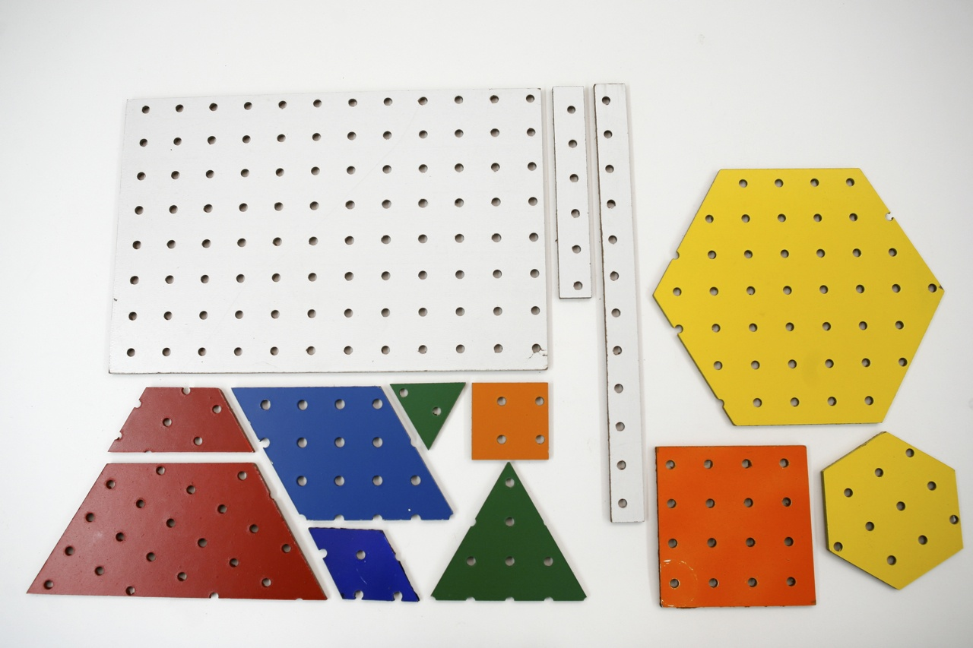
Figure 1: Classroom set of pegboard Mech-a-Blocks. Clockwise from top left: base; large & small strips, hexagons, squares, triangles, rhombuses and trapezoids
Type | Description | Quantity | Used in these Lessons:
Templates for making  cut-out figures | cat (6/ sheet) | 5 sheets | 8
 | Mouse (6/ sheet) | 5 sheets | 8
 | Butterfly (6/ sheet) | 5 sheets | 9
 | Net (2/ sheet) | 15 sheets | 9
Butterfly-net MechAnimation |  | 1 | 3, 9
Brass paper fasteners | 2” (box of 100) | 5 boxes | 1-10
 | 1” (box of 100) | 2 boxes | 5, 6 &10
Manufactured mechanisms | Fireplace tongs | 1 | 1, 6
 | Coat hooks | 1 | 1, 6
Table 2: Other materials supplied for K-1 Mech-a-Blocks Curriculum

Craft supplies
Google eyes | Small bag assorted sizes | 1 | 10
Feathers | Small bag, assorted shapes & colors | 1
Foam stickers | Small bag, assorted shapes & colors | 1
Pipe cleaner | Assorted colors | 30
Cocktail umbrella | Assorted colors, 4” diam. | 30
Pom-poms | Small bag, assorted sizes and colors | 1

Lesson 1: What can you make?
Essential Question
What are Mech-a-blocks and how can we use them to build things?
Task
In this introductory lesson, children become acquainted with Mech-a-blocks, try to make things from them, and develop their thinking about how to use these materials.
Standards
CCLS – ELA:

Writing: Text types and purposes; Production and distribution of writing

Speaking and Listening: Presentation of knowledge and ideas
Language: Vocabulary acquisition and use
CCLS – Math:
Standards for Mathematical Practice: MP 4: Model with mathematics
Measurement and Data (K.MD): Describe and compare measurable attributes
Measurement and Data (1.MD): Measure lengths indirectly and by iterating length units; Represent and interpret data
Geometry(K.G): Identify and describe shapes; Analyze, create, compare and compose shapes
Geometry (1.G): Reason with shapes and their attributes
NGSS:
Science & Engineering Practices 3. Planning and carrying out investigations; 8. Obtaining, evaluating and communicating information
Cross-cutting Concepts 2. Cause and effect: mechanism and prediction; 3. Scale, proportion and quantity
Disciplinary Core Ideas ETS1: Engineering Design
Outcomes
- Students should be able to construct with Mech-a-Blocks, explain how they did it, and demonstrate or describe any moving parts.
Assessment
Objective: | Below (1) | Approaching (2) | Proficient (3) | Advanced (4)
A. Build a mechanism or structure | Unable to make one | Makes one but can’t explain how it was done | Makes one, explains how it was done and demonstrates or describes moving parts | Makes one, explains how it was done, demonstrates or describes moving parts and offers advice to other students

Advance Preparation
- Prepare bins of materials for groups of students (4-5 per group)
- Make copies of worksheets if not using science journals
- Create a properties chart for the Mech-a-blocks (see below)
 | Triangle | Square | Rhombus | Trapezoid | Hexagon | Circle
Number of Sides
Number of Corners
Materials
- Classroom set of pegboard Mech-a-Blocks
- Manufactured mechanisms: fireplace tongs, expandable coat hooks, nutcrackers, scissors, pliers, salad tongs, etc.
Procedure
1. Introduce the Mech-a-blocks during a class meeting:
- We have some new materials in the science area. We call them Mech-a-blocks. Can you describe this piece (holding up a green triangle)?
- Where can we find other shapes like this?
Children may identify a triangular attribute block or building block.
- How do these compare to attribute blocks or pattern blocks?
Children may say it’s bigger, the color is different, it’s made of a different material, this one has holes but the others don’t.
2. Focus their attention on the holes and the fasteners:
Someone is likely to notice the holes in the pegboard pieces. Ask the children what they are good for:
- What we can do with the holes?
To help out, say, “Here’s a clue. There is one other thing in the area: this small container with fasteners.”
- Does anyone know how these work? What can you do with them? How do you use them?
- Do you know how to attach two things with a fastener, so they can’t come apart?
Every child may not realize that the fastener can be inserted into two holes in order to attach two pieces, and then the two ears of the fastener can be bent apart, to keep the fastener from coming out. Once someone makes this discovery, it is likely to catch on quickly!
3. Encourage them to make something:
Populate the science area with manufactured mechanisms. These will become the focus of Lesson 6, but it is a good idea to make them available from the very beginning, as sources for ideas.
- When you are in the science area, you can use any of these pieces (indicating the Mech-a-Blocks shapes). See what you can make.
- When you make something special you want to share, you can keep it until you have had a chance to share it, but after that, we will take the pieces apart so we can use them again.
Provide plenty of room and time to experiment. Children have made spaceships, cameras, houses, birds, camels, faces, tables, as well as abstract designs. Some first constructions are shown in Figures 1 and 2.
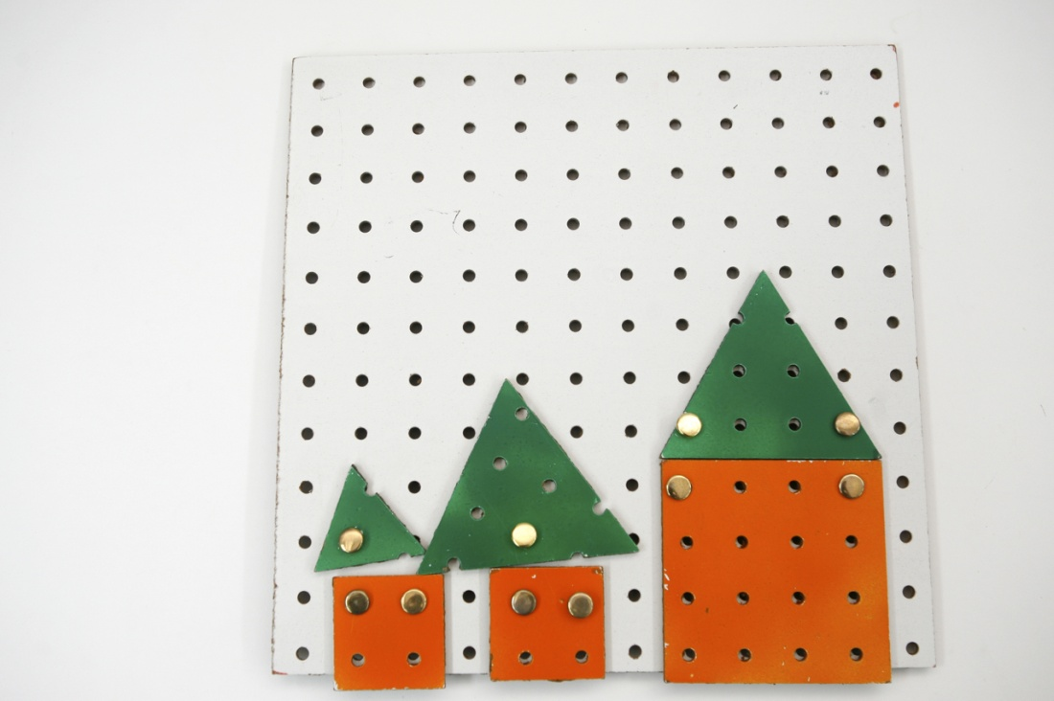
Figure 1: Houses made from Mech-a-Blocks
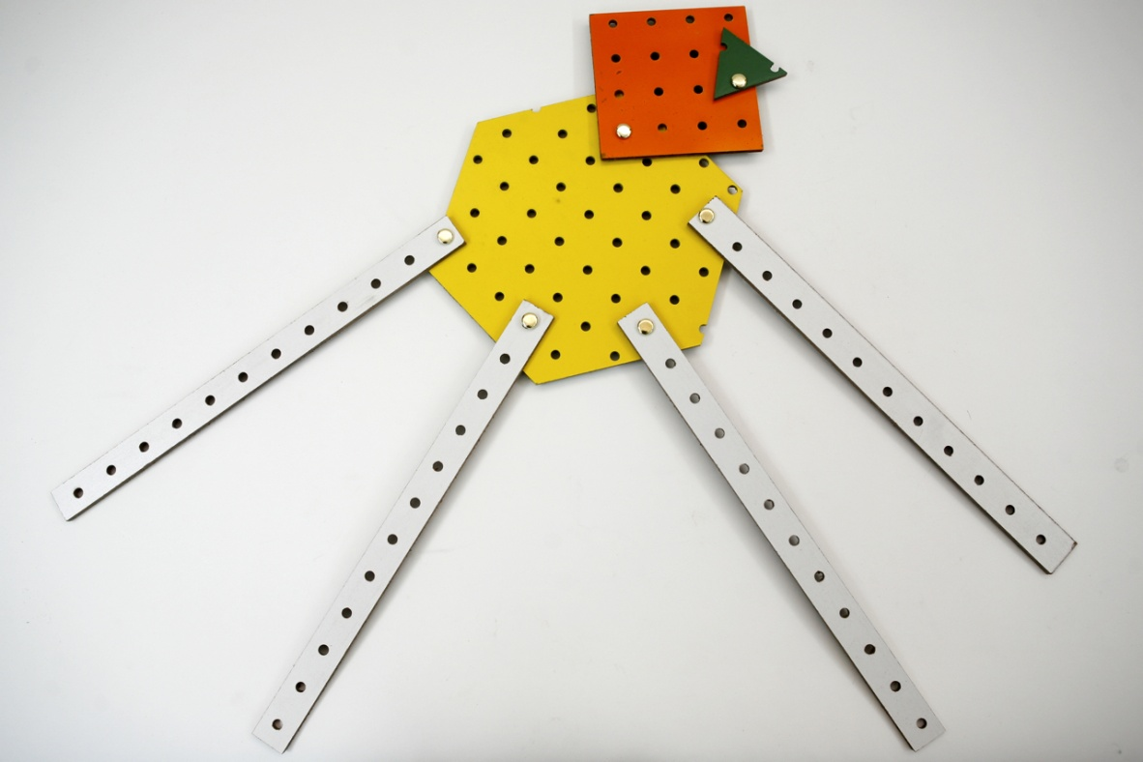
Figure 2: Four-legged creature made with Mech-a-Blocks

4. Discussion
The children will make a variety of things. Look closely at the processes and products of the work. Select some constructions that are very different from one another, and ask the children who made them to show them to the rest of the class. Before each child presents his or her work, ask:
- What does it represent?
- What do you have to do to make things move?
- How will it move?
After the rest of the class has guessed, allow the child who made it to demonstrate it and discuss what it represents. Then guide the class in thinking and talking about each construction:
- How is yours similar to what ____ made?
- How is it different?
- What problems did you have in making it? Did anyone else have a similar problem? What did you do to fix it?
Save their constructions for the next lesson
Note: This “lesson” might last for several periods or more. It should continue as long as children are coming up with new ideas, and following them through.
Word bank
Base, Fastener, Pivot, Strip, Shape
Science Notebooks
- Record what you have made, using words and pictures.

Name: __________________________ Date: ______________________
Mech-a-Blocks What I Made

Lesson 2: Structures and Mechanisms
Essential Question
What are the similarities and differences between structures and mechanisms?
Task
By now, there should be numerous examples of children’s work. Children next examine their constructions closely, and investigate some of the patterns that connect form and function. These patterns involve the different uses of fasteners, which determine whether or not the constructions have moving parts.
Standards
CCLS – Math:
Standards for Mathematical Practice: MP 4: Model with mathematics
Measurement and Data (K.MD): Describe and compare measurable attributes
Measurement and Data (1.MD): Measure lengths indirectly and by iterating length units; Represent and interpret data
Geometry(K.G): Identify and describe shapes; Analyze, create, compare and compose shapes
Geometry (1.G): Reason with shapes and their attributes
CCLS – ELA:

Writing: Text types and purposes; Production and distribution of writing

Speaking and Listening: Comprehension and collaboration; Presentation of knowledge and ideas
Language: Vocabulary acquisition and use
NGSS:
Science & Engineering Practices 1. Asking questions and defining problems; 3. Planning and carrying out investigations; 8. Obtaining, evaluating and communicating information
Cross-cutting Concepts 2. Cause and effect: mechanism and prediction; 4. Systems and system models; 6. Structure and function; 7. Stability and change
Disciplinary Core Ideas PS2: Motion and Stability: forces and interactions; ETS1: Engineering Design
Outcomes
- Students should discover that a mechanism uses at most one fixed fastener to attach a piece to the base, while a structure uses two or more fixed fasteners to attach a piece to the base.

Assessment
Objective: | Below (1) | Approaching (2) | Proficient (3) | Advanced (4)
A. Differentiate between a mechanism and a structure | Unable to make either one | Does one or the other but not both; or does both but can’t explain the differences | Can make both and articulate the similarities or differences in some form | Can make both and articulate the similarities and differences clearly
B. Can turn a structure into a mechanism and a mechanism into a structure | Unable to do either one | Does one or the other but not both | Can do both transformations | Can do both transformations and articulates the process
Materials
- Mech-a-Blocks constructions from previous lesson
Advance Preparation
- Make examples of structures and mechanisms for demonstration purposes
- Make copies of worksheets if not using science journals

Procedure
1. Focusing on structures vs. mechanisms:
Select some constructions that have moving parts and some that don’t. Demonstrate the difference, by holding the base of each one, and trying to make other parts move. The base is usually the largest piece. It’s the piece you hold steady while trying to make the other parts move over it. Anything with moving parts is called a mechanism, while anything that can move only as a whole is called a structure. Write these two words on chart paper.
Help students sort their constructions into the two main categories, mechanisms and structures.
2. What do fasteners do? Focus students’ attention on how they used fasteners. Use examples of their work to show three basic ways:
- A fastener that goes through one piece only: What (if anything) would be different about the way things would work if it weren’t there?
- A fastener that goes through the base and another piece: What is the job of this fastener? Which pieces can move and which ones can’t?
- A fastener that goes through two pieces but not the base: What is the job of this fastener? Which pieces can move and which ones can’t?
Help them see that type a. just moves with the part it is attached to – it does not change anything about the movement of the other parts. Because it doesn’t really do anything, we’ll call it a phony fastener! The second type (b.) is a fastener that cannot move itself, because it is attached to the base, but it may allow other parts to move, depending on whether there is a mechanism or a structure. This one we’ll call a fixed fastener or fixed pivot, if it allows something to move. Type c. fasteners generally allow one part to move another part. Since these fasteners can move with the parts, we call it a floating pivot.
3. What makes something a mechanism or a structure? Using the discussion about fasteners, return students’ attention to the categories of mechanisms and structures. Demonstrate one of each, and have students identify the type b. fasteners in each one. Then ask them to look at their own constructions:
- In a structure, what do you notice about the number of fasteners attaching a part to the base?
- In a mechanism, what do you notice about the number of fasteners attaching a part to the base?

Word bank
Cause-and-effect, Fixed fastener, Fixed pivot, Floating pivot, Input, Mechanism, Output, Phony fastener, Structure, System
Science Notebooks
- Using words and pictures, show what happens when you try to move parts of what you made.

Name: ___________________________________ Date: _______________________
Mechanisms
Using words and pictures show what happens when you try to move something you made.

Lesson 3: A Mechanism with an Input that Controls it
Essential Question
How can I use one link to make another link move?
Task
This lesson begins with inputs and outputs and engages students in identifying them. Children are then challenged to figure out how to use one link to make another one move. To do so, they will have to invent the floating pivot, which attaches two links to each other but not to the base.
Standards
CCLS – ELA:

Writing: Text types and purposes; Production and distribution of writing

Speaking and Listening: Presentation of knowledge and ideas
Language: Vocabulary acquisition and use
NGSS:
Science & Engineering Practices 1. Asking questions and defining problems; 3. Planning and carrying out investigations; 8. Obtaining, evaluating and communicating information
Cross-cutting Concepts 1. Patterns; 2. Cause and effect: mechanism and prediction; 5. Energy and matter: flows cycles and conservation; 6. Structure and function; 7. Stability and change
Disciplinary Core Ideas PS2: Motion and Stability: forces and interactions; ETS1: Engineering Design

Outcomes
- Students should be able to identify the input and output of a mechanism, and tell if the input is a separate piece that controls the output
- Students should know how to make a mechanism with a separate input.

Assessment
Objective: | Below (1) | Approaching (2) | Proficient (3) | Advanced (4)
A. Able to identify an input and output | Unable to identify either one | Identifies them backwards | Identifies them correctly | Identifies them correctly and models how to add an input that controls the lever
Advance Preparation
- Make examples of inputs that control outputs. (see figure 3)
- Make copies of worksheets if not using science journals

Materials
- Classroom set of pegboard Mech-a-Blocks
- One Butterfly-Net MechAnimation
- Post-Its™ or markers

Procedure
1. Inputs, outputs and systems:
Ask each student to quickly make a simple mechanism using one base, one fastener and one Mech-a-Blocks shape. In a whole-class meeting, ask the students who made them to demonstrate how to operate them. Ask the rest of the class to notice:
- What is the part ________ is pushing (or pulling) to make it work?
- Name other things that you have to do something to, to make them work.
Examples might include lights, pencil sharpeners, computers, video games, TVs, boom boxes, etc.
- What is the part you have to operate on each of these?
Help them develop a name for this part: the input or handle. Using the same Mech-a-Blocks constructions, ask the complementary question:
- When you operate this input, what is it you want to happen?
Ask the same question about the other examples they have suggested: lights, pencil sharpeners, computers, video games, TVs, boom boxes, etc. Develop the name for the action you want to happen: the output. There’s also a word for anything that has an input and an output: it’s called a system.
2. Levers and handles
Demonstrate the Butterfly-net MechAnimation (see Figure 1). Ask students:
- What story is this telling?
- What do you think is making the net move?
- Where is the input? How do you know?
- Where is the output? How do you know?
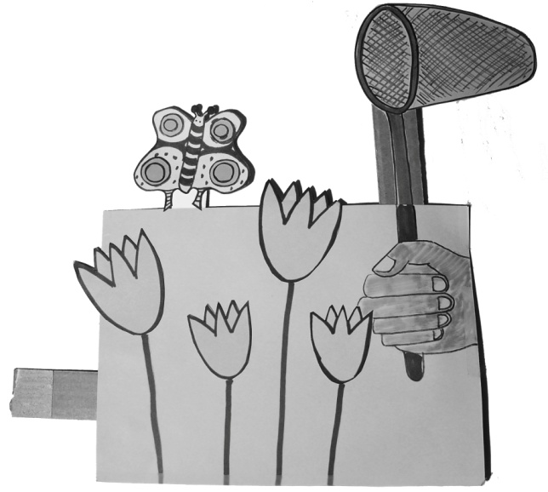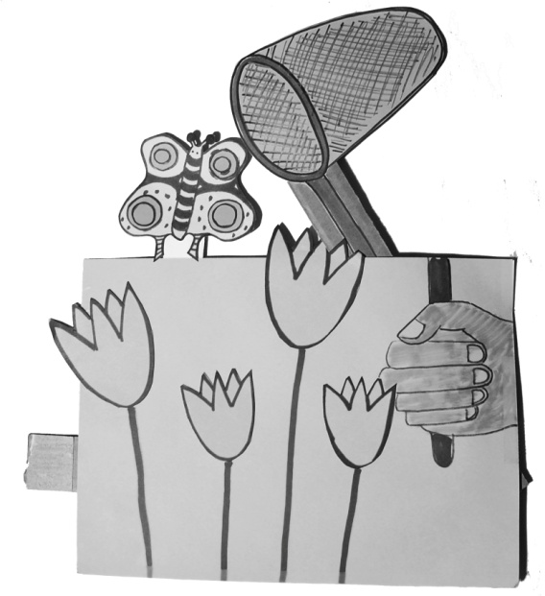
Figure 1: Butterfly MechAnimation
- How does this input control the output?
Then challenge them to:
Invent a way to make a handle for this mechanism. An input is a piece like this one (indicating input link of Butterfly MechAnimation) that I can use to control the output without touching it.
As an example, hold a pegboard strip near a simple lever attached to a base and ask, “How could I use this as the input to this mechanism?”
Allow a few minutes for them to try to come up with a way to make a separate input that controls the lever. Then convene the class again, so they can report on what they did. Students are likely to think of simply pushing the lever with the input, rather than with their fingers directly. Congratulate them on that solution, but then use their mechanism to demonstrate what happens when you try to pull the lever back with the input. Because they are not connected, the input will not be able to pull it back.
- What do you notice about this?
- Why doesn’t it work when I try to make it go the other way?
Challenge them to think of a way around this problem, and provide a few more minutes for them to experiment.
3. The floating pivot: At least one student will probably come up with the idea of attaching the input to the lever with a fastener that goes through the two moving parts but not through the base. We will call this type of pivot a floating pivot. If students have not invented the floating pivot yet, make such a mechanism yourself, as in Figure 2.
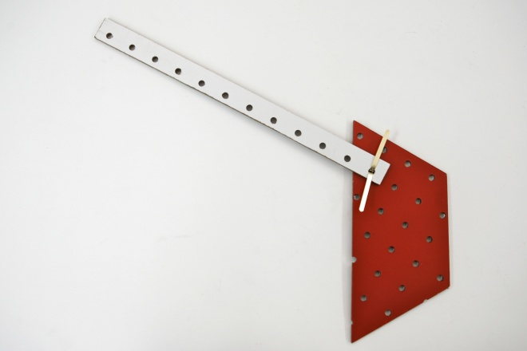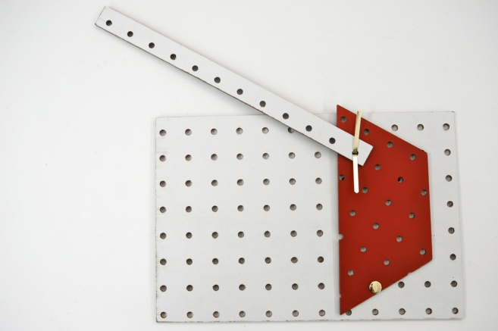
Figure 2: Assembling a lever with an input: (left)) connecting the input and the lever with a floating pivot, legs up; (right) attaching the lever to the base with a fixed pivot
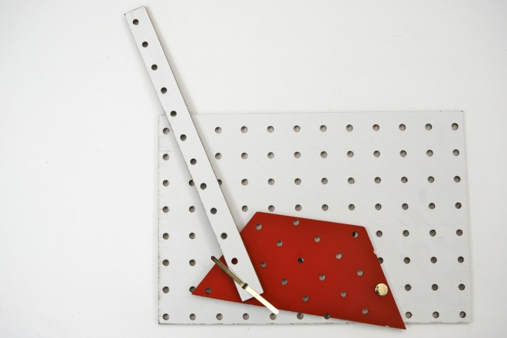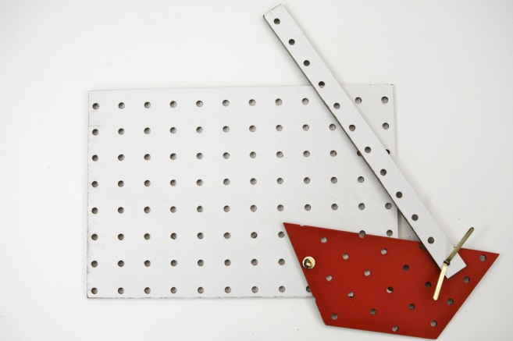
Figure 3: Showing how the input can control the lever moving it to other positions
Use Post-Its ™ or markers to label the two pivots in different colors, such as red for the fixed pivot and green for the floating pivot. Operate the mechanism so the whole class can see it, and ask:
- What difference do you see between how the red and the green pivot work?
- Why does the input now control the output?
Then challenge them again to make mechanism where one piece controls another.
4. Discussion: Lead a discussion based on what children have made. After each child presents his or her work, ask the class to chime in:
- What do you think about ______’s mechanism? Where is the input? Where is the output? What controls what?
- Did anyone make anything similar? What was similar about it? What was different?
- Did anyone have the same problem ______ did? What did you do to solve it? What advice do you have for ______?

Word bank
Control, Fixed pivot, Floating pivot, Input controlling a lever, Lever
Worksheets
Science Notebooks
- Using words and pictures, explain how you made a mechanism with an input, which controls it.

Name: ___________________________________ Date: _______________________
Draw your mechanism. Label the input and the output. Write about what you made.
I made a

Lesson 4: Mechanism Diagrams
Essential Question
How do we draw a mechanism so that our drawing shows what it can do?
Task
Develop a common set of requirements for diagramming mechanisms.
Standards
CCLS – ELA:

Writing: Text types and purposes; Production and distribution of writing

Speaking and Listening: Presentation of knowledge and ideas
Language: Vocabulary acquisition and use
CCLS – Math:
Standards for Mathematical Practice: MP 4: Model with mathematics
Measurement and Data (K.MD): Describe and compare measurable attributes
Measurement and Data (1.MD): Measure lengths indirectly and by iterating length units; Represent and interpret data
Geometry(K.G): Identify and describe shapes; Analyze, create, compare and compose shapes
Geometry (1.G): Reason with shapes and their attributes
NGSS:
Science & Engineering Practices 2. Developing and using models; 5. Using mathematics and computational thinking; 8. Obtaining, evaluating and communicating information
Cross-cutting Concepts 3. Scale, proportion and quantity; 4. Systems and system models; 6. Structure and function

Outcomes
- Students should be able to represent a mechanism using a diagram, and understand how an effective diagram could be used to reconstruct the real thing

Assessment
Objective: | Below (1) | Approaching (2) | Proficient (3) | Advanced (4)
A. Diagram their own mechanism | Diagram is not representational | Diagram has most of the elements; representational, labels symbols and a key | Diagram has all of the elements; representational, labels symbols and a key | (3) + Diagram is not just representational but has an air of realism

Advance Preparation
- Make copies of worksheets if not using science journals

Materials
- Classroom set of pegboard Mech-a-Blocks
- Simple mechanisms with separate inputs from Lesson 3
- Chart paper and markers
- Drawing paper and pencils

Procedure
1. Why make diagrams? In a whole-class meeting, introduce the recording problem: Pegboard is recyclable, and we can use it again for something else. You can’t take it home, because it costs too much. Suppose you made something, and then planned to take it apart, so you could use the pieces for something new.
- How could you make a record of what you made, so you could make it again, or compare it with the new mechanism?
- How could you let your parents or a friend know about a mechanism you made?
Conduct a discussion about these issues. Students will probably suggest making drawings.
2. Thinking about diagrams. A diagram looks like a drawing, but its purpose is different. A drawing is supposed to look as much as possible like the real thing. A diagram represents the important features, but not everything – just what you need in order to make it again. Provide some diagrams of your own as examples. Some of them could deliberately be hard to read. Engage students in thinking about what makes a diagram easy or hard to figure out:
- How much of your mechanism do you need to show, in order for someone to know what you did, or for you to remember later?
- Which holes are important enough to show on your diagram?
3. Making diagrams. Provide newsprint and markers, or paper and pencils, and encourage students to record their constructions in any way they choose.
4. Gallery walk. Once students have created their own diagrams, post them around the room, and conduct a discussion about what you can learn from each one. Find positive features of each one, and use the discussion to develop ideas about what makes a good diagram. You might also compare some of the drawings with the original mechanisms, to look for similarities and differences. The key question is:
- Would another student be able to make the same mechanism you made if all the information they had was in the diagram?
- If not, what would you need to do to make the diagram easier to use?
To explore this issue, you could deliberately make a mechanism incorrectly from a student’s diagram that is missing some information, such as the distinction between fixed and floating pivots.
5. Using symbols in diagrams. Develop a list of symbols already in use in your classroom or school, such as red and green for which doorways to use, bathroom symbols, fire extinguisher symbols, etc. Connect these symbols in everyday use to the symbols they used in their diagrams:
- How did we use symbols to show common things, so we don’t have to make a complete drawing each time?
- What other things would you like to have symbols for?
Help them think about which kinds of things are really different, and therefore need to have different symbols. For example,
- How could we use symbols to tell whether something is a fixed pivot or a floating pivot?
Word bank
Diagram, Drawing, Symbol
Science Notebook
- At the end of the period, ask each student to remove his or her diagram from the wall and attach it to the Science Notebook.

Name: ___________________________________ Date: _______________________
Mech-a-Blocks Mechanism Diagrams

Lesson 5: Modeling Mechanisms
Essential Question
What can we use to create models of our pegboard mechanisms?
Task
In this lesson, students compare two different kinds of materials for making mechanisms: pegboard and cardstock. Then they create cardstock models of their pegboard mechanisms. Finally, they look at other examples of modeling, and explore how a model is both similar to, and also different from the real thing.
Standards
CCLS – ELA:

Speaking and Listening: Comprehension and collaboration; Presentation of knowledge and ideas
Language: Vocabulary acquisition and use
CCLS – Math:
Standards for Mathematical Practice: MP 4: Model with mathematics
Measurement and Data (K.MD): Describe and compare measurable attributes
Measurement and Data (1.MD): Measure lengths indirectly and by iterating length units; Represent and interpret data
Geometry(K.G): Identify and describe shapes; Analyze, create, compare and compose shapes
Geometry (1.G): Reason with shapes and their attributes
NGSS:
Science & Engineering Practices 2. Developing and using models; 5. Using mathematics and computational thinking; 8. Obtaining, evaluating and communicating information
Cross-cutting Concepts 3. Scale, proportion and quantity; 4. Systems and system models; 6. Structure and function
Disciplinary Core Ideas PS2: Motion and Stability: forces and interactions; ETS1: Engineering Design

Outcomes
- Students should be able to construct a cardstock model of a pegboard mechanism, and be able to compare the operation of the model with that of the original, listing pros and cons of each.

Assessment
Objective: | Below (1) | Approaching (2) | Proficient (3) | Advanced (4)
A. Identify the benefits and drawbacks of pegboard mechanisms and cardstock models | Can articulate either the benefits or drawbacks of pegboard mechanisms or cardstock models | Can articulate either the benefits or drawbacks of pegboard mechanisms and cardstock models | Can articulate the benefits and drawbacks of pegboard mechanisms and cardstock models | (3) + can correct mistakes on a cardstock model to make it more like the original
Advance Preparation
- Prepare group sets of cardstock Mech-a-blocks

Materials
- Children’s Mech-a-Blocks constructions from previous lessons
- Classroom set of cardstock Mech-a-Blocks

Procedure
1. Comparing materials: Distribute the mechanisms from previous lessons. Provide each group with some of the cardstock Mech-a-Blocks shapes.
- How are these cardboard pieces similar to the pieces you have been working with? How are they different?
  - What would happen if I made a mechanism out of these cardboard materials?
  - What would be better about mechanisms made from cardboard?
  - What would be better if I made them from pegboard?
2. Cardstock models of pegboard mechanisms. Review the diagramming activities from the previous lesson. Then present another idea for keeping a record of their work:
- What if we had thin cardboard pieces in the same shapes and colors as the pegboard?
Show them the shapes, strips and bases cut from cardstock.
- How could you use these pieces to make a model of your mechanism?
They could attach these pieces with fasteners, and make them both look and work like what they made in pegboard. These cardstock shapes are plentiful, so they could take these models home, and even take extra cardstock home to make new mechanisms.
Provide cardstock shapes and fasteners, and allow students to construct models of their original constructions:
Use this cardstock to make a mechanism that moves the same way as the one you made before, although it is made of a different material.
3. Improving the accuracy of the models:
The models students make at first will probably not be very precise. Use some of the students’ examples to highlight this problem. If necessary, take them apart, and hold similar pieces one on top of the other to demonstrate the differences in hole locations.
- Why doesn’t this model work the same way as the original?
- Why is it important for the holes to be in the same places in the model as in the original?”
- How could we make sure to put the holes in the same places in the model as in the original?
4. Discussion of models: In a brief whole-class wrap-up discussion, ask students for examples of models. They might suggest model cars, planes or boats; doll houses, clothing or furniture; stuffed animals; etc. If they don't include the mechanism models they have just made, ask if those should be added to the list. Then construct a class chart showing how each type of model is similar and different from the original.
Finally, conduct a brief discussion about these topics:
- How were the new models better than the first models? How could you tell?
- What made the new models better?
- What is similar between the model and the original mechanism? Why are these similarities important?
- What is different between the model and the original? How important are these differences?
- What is a model good for?

Word bank
Cardstock, Model, Pegboard
Science Notebook
- Use words and pictures to show how you made your model

Lesson 6: Modeling Manufactured Mechanisms
Essential Question
Can we make models of simple manufactured mechanisms?
Task
This lesson provides another perspective on modeling. Students are encouraged to look at existing mechanisms, such as scissors, tongs and extension hooks, and identify their basic mechanical parts. They then capture the underlying forms by making models of these devices in pegboard or cardstock.
Standards
CCLS – ELA:

Speaking and Listening: Comprehension and collaboration; Presentation of knowledge and ideas
Language: Vocabulary acquisition and use
CCLS – Math:
Standards for Mathematical Practice: MP 4: Model with mathematics
Measurement and Data (K.MD): Describe and compare measurable attributes
Measurement and Data (1.MD): Measure lengths indirectly and by iterating length units; Represent and interpret data
Geometry(K.G): Identify and describe shapes; Analyze, create, compare and compose shapes
Geometry (1.G): Reason with shapes and their attributes
NGSS:
Science & Engineering Practices 1. Asking questions and defining problems; 6. Constructing explanations and designing solutions
Cross-cutting Concepts 1. Patterns; 2. Cause and effect: mechanism and prediction; 4. Systems and system models; 5. Energy and matter: flows cycles and conservation; 6. Structure and function; 7. Stability and change
Disciplinary Core Ideas PS2: Motion and Stability: forces and interactions; ETS1: Engineering Design; ETS2: Links among Engineering, Technology and Society
Outcomes
- Students should be able to construct a model of a manufactured mechanism, and be able to compare the operation of the model with that of the original.
Assessment
Objective: | Below (1) | Approaching (2) | Proficient (3) | Advanced (4)
A. Identify the benefits and drawbacks of manufactured mechanisms and pegboard models | Can articulate either the benefits or drawbacks of manufactured mechanisms or pegboard models | Can articulate either the benefits or drawbacks of manufactured mechanisms and pegboard models | Can articulate the benefits and drawbacks of manufactured mechanisms and pegboard models | (3) + can correct mistakes on a pegboard model to make it more like the original
Advance Preparation
- Collect simple mechanisms for students to construct models of
- Make copies of worksheets if not using science journals

Materials
- Classroom set of Mech-a-Blocks: both cardstock and pegboard.
- Manufactured mechanisms that children can model. These could include scissors, pliers, tweezers, garlic presses, nut crackers, salad tongs, jar openers, fireplace tongs, expandable door hooks, retractable mirrors, and adjustable-arm desk lamps See Figure 1.
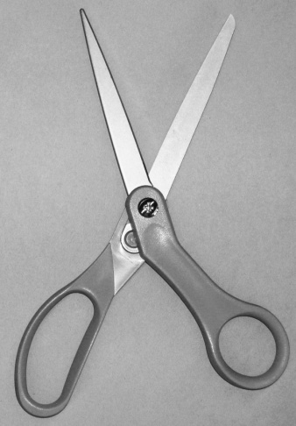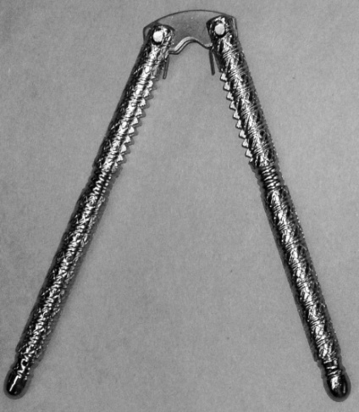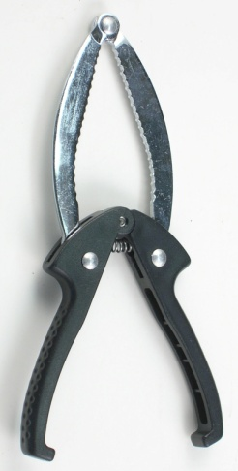
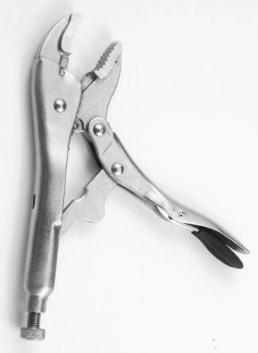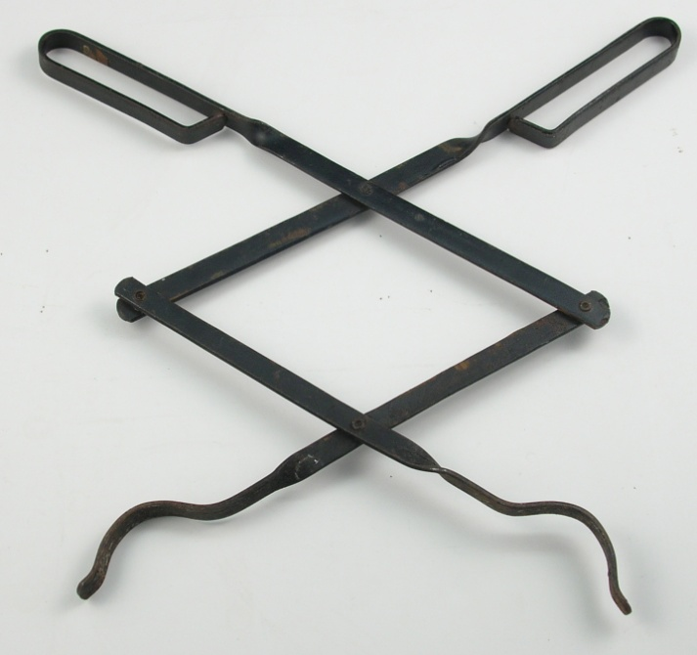
Figure 1: Sample mechanisms for modeling (clockwise, from top left):
scissors, nutcracker, jar opener, fireplace tongs, vise grips,

Procedure
1. Review of modeling. Review the concept of modeling from the previous lesson: a model keeps essential features of the original, but leaves out those that are unimportant and/or get in the way of understanding. For example, a model of a Mech-a-Blocks construction doesn’t need to include all the holes that are not used, but those that are used need to be in the right locations.
Today we are going to make a different kind of model. We’re going to start with something someone else made, and see if we can make something that works the same way.
Provide examples of commercially made mechanisms. Each one should consist of links and pivots that can easily be modeled in pegboard or cardstock. Figure 1 shows five examples.
2. Modeling mechanisms made by someone else. For this activity, students should work in pairs. Give each pair a choice between pegboard and cardstock, and provide these materials, as well as fasteners, pencils for tracing, and crayons or markers, Post-Its™, paper, tape and scissors for decorating.
As students are working, visit the groups and assist them in thinking about how to proceed. What features of the original are important and which are not important? How are they deciding what sizes and shapes to use for the pieces? What method are they using to record the hole locations?
This work may take more than one period. Provide time for them to continue until they are satisfied with their models.
3. Whole-class discussion. Provide time for each pair to share their model. Ask each pair to talk about these issues:
- What was the object you were trying to model? What is it used for?
- What did you do to make your model? How many pieces did you need? How many fasteners? How did you know?
Review the issues about accuracy that came up in Lesson 5.
- How is your model different from the real thing? How is it similar?
- What problems did you run into? What did you learn?
Science Notebook
- What did you make a model of?
- How did you make your model?
- How is it different from the real thing? How is it similar?

Name: ___________________________________ Date: _______________________
What I Made a Model Of: My Mech-a-Blocks Model
Similarities
Differences

Lesson 7: Which way will it go?
Essential Question
What directions do the ends of a see-saw go in?
Task
This lesson compares the directions of the input and the output of a see-saw. What direction do the figures on the two sides go in? How is the design changed to make both figures go the same way?
Standards
CCLS – ELA:

Speaking and Listening: Comprehension and collaboration; Presentation of knowledge and ideas
Language: Vocabulary acquisition and use
CCLS – Math:
Measurement and Data Kindergarten (K.MD): Describe and compare measurable attributes
Measurement and Data First Grade (1.MD): Measure lengths indirectly and by iterating length units; Represent and interpret data
NGSS:
Science & Engineering Practices 2. Developing and using models; 3. Planning and carrying out investigations; 4. Analyzing and interpreting data; 8. Obtaining, evaluating and communicating information
Cross-cutting Concepts 1. Patterns; 2. Cause and effect: mechanism and prediction; 4. Systems and system models; 6. Structure and function; 7. Stability and change
Disciplinary Core Ideas PS2: Motion and Stability: forces and interactions; ETS1: Engineering Design

Outcomes
- Students should learn to distinguish between up and down movement, and compare two movements to see if they are in the same or opposite directions.
- They should learn that when the fixed pivot is in between the input and output, the two motions will be in opposite directions. If both input and output are on the same side of the fixed pivot, the input and output will move in the same direction.

Assessment
Objective: | Below (1) | Approaching (2) | Proficient (3) | Advanced (4)
A. Can predict describe the trajectory of the cat and mouse correctly | Unable to predict | Predicts incorrectly but can describe the movement after observation | Predicts correctly and can describe the movement after observation | (3)+ Can articulate how the input and output can move in the same direction

Advance Preparation
- Cut out color copies of cat and mice
- Hole punch cat and mice
- Make copies of worksheets if not using science journals

Materials
- Mech-a-Blocks pegboard bases and strips
- Cut-out figures of cat and mouse
- Tape for attaching cut-out figures to pegboard
- Markers and chart paper

Procedure
1. The see-saw: Demonstrate a Mech-a-blocks model of a see-saw, such as the one in Figure 1. Do not operate it yet.
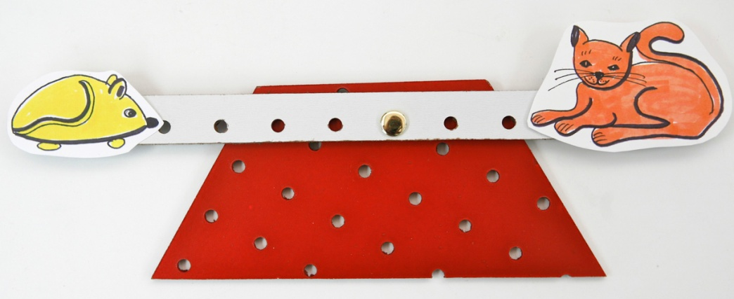
Figure 1: Mech-a-blocks see-saw
- Which way the mouse will go if the cat goes up?
- What about if the cat goes down?
Record their answers, using a diagram and arrows on chart paper. See Figure 2.
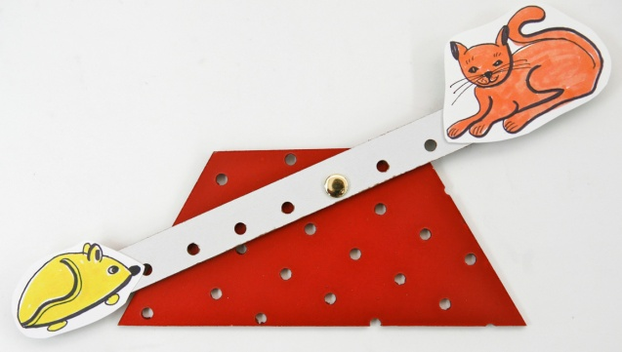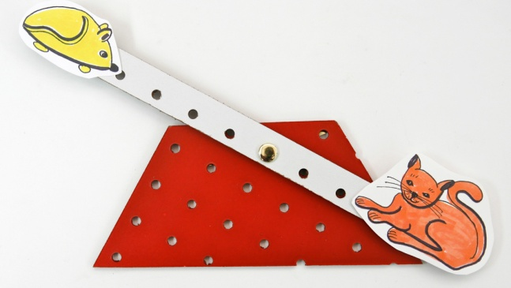
Figure 2: Which way will the mouse go?
Then provide each student with cat and mouse cut-outs, and ask each one to make his or her own see-saw. Ask them to try the experiment with their own constructions:
- If your cat goes up, which way does your mouse go?
- If your cat goes down, which way does your mouse go?
Next, review the words “same,” “opposite” and “direction:”
- Direction tells which way something is going. What direction did I push the mouse? ____. What direction did the cat go? ____
- Same means that if one goes up, the other goes ___. If one goes down, the other one goes ____.
- Opposite means that if one goes up, the other goes ___. If one goes down, the other one goes ____.
Finally, ask whether the see-saw makes the cat and mouse go in the same directions or opposite directions. Write the answer on chart paper.
2. Making them go the same way: Ask the students:
- On the see-saw, the mouse and the cat go in opposite directions. What if the cat wanted to go in the same direction as the mouse? How could I change this see-saw to make that happen?
Provide time for them to experiment with their Mech-a-Blocks. Try out any suggestion they come up with and test it to see if the input and output go in the same direction.
If they don’t come up with it, present your own solution: first, remove the see-saw from the base. Then attach the cat a little to the right of the mouse. See Figure 3.
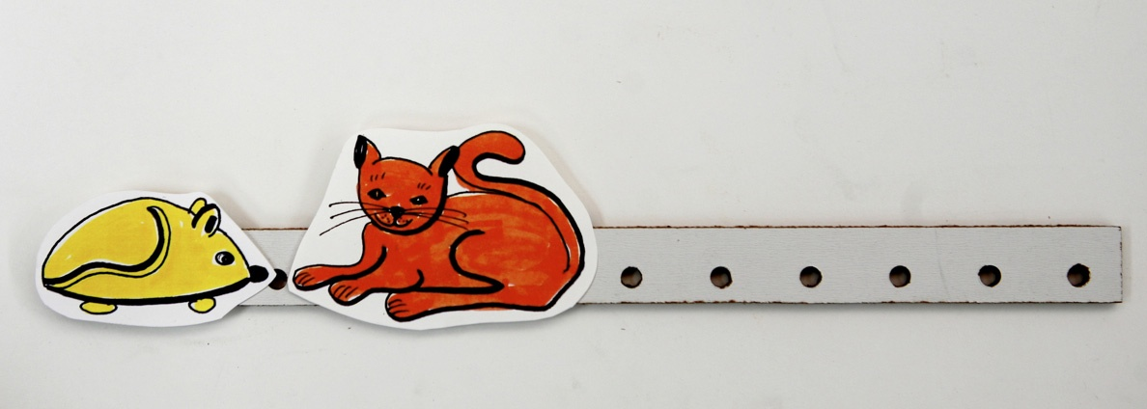
Figure 3: Putting the cat near the mouse
Finally, reattach the see-saw to the base, placing the pivot far enough to the right so they both fit comfortably on the left side, as in Figure 4.
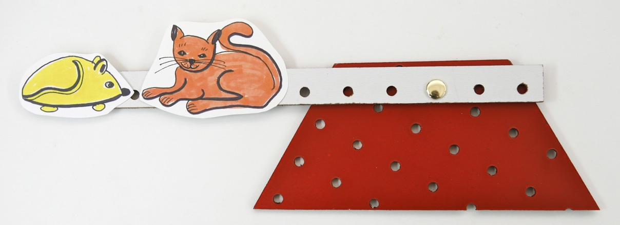
Figure 4: See-saw is re-attached to the base, leaving room for cat and mouse on the same side
of the fixed pivot.
3. Class discussion. Ask students whether or not this works, and if it does, what you changed to make it work. See Figure 5.
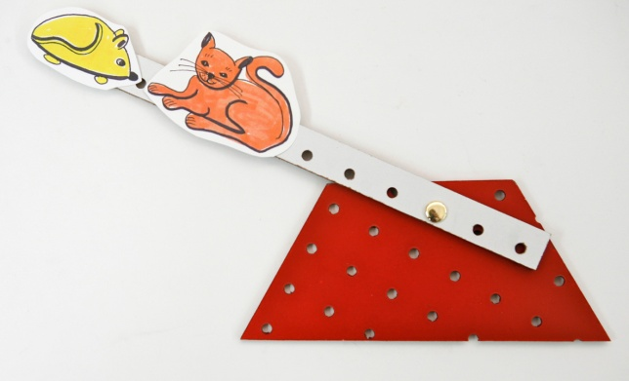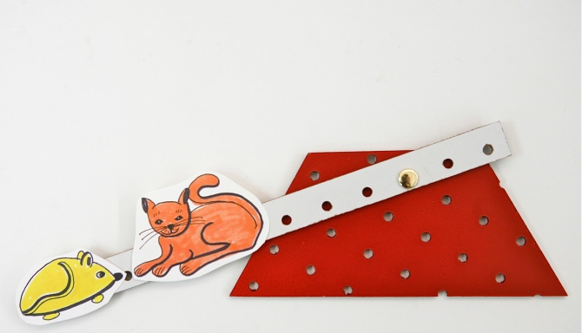
Figure 5: Now they both go the same way
3. Discussion: Conduct a whole-class discussion comparing the two kinds of see-saws.
- What do you notice about where the fixed pivot has to be when the cat and mouse go in opposite directions?
- What has to be true for them to go in the same direction?

Word bank
Direction, Same, Opposite
Science Notebook
- Draw your see-saw. Use arrows to show which way the mouse goes when the cat goes down.
- Draw a see-saw that makes the cat and mouse go in opposite directions.
- Draw a see-saw that makes the cat and mouse go in the same directions.

Name: ___________________________________ Date: _______________________
Which Way Will it Go?

Opposite Same
If the mouse goes __________, If the mouse goes __________,

then the cat goes __________. then the cat goes __________.

If the mouse goes __________,

then the cat goes __________.

Lesson 8: How to Get a Better Ride
Essential Question
How can we get the mouse or the cat to have a better ride?
Task
This lesson focuses on distance traveled by an input or output of a lever. Students discuss what makes for a “better ride” on a see-saw: is it better to go further or not as far? Based on their decision, students notice whether the cat or mouse gets a better ride, when both are traveling in the same direction. Then they figure out how to rearrange the cat and mouse so the other one gets the better ride. Finally, they try to adjust the distances traveled when the directions are opposite.
Standards
CCLS – ELA:

Speaking and Listening: Comprehension and collaboration; Presentation of knowledge and ideas
Language: Vocabulary acquisition and use
CCLS – Math:
Measurement and Data Kindergarten (K.MD): Describe and compare measurable attributes
Measurement and Data First Grade (1.MD): Measure lengths indirectly and by iterating length units; Represent and interpret data
NGSS:
Science & Engineering Practices 2. Developing and using models; 3. Planning and carrying out investigations; 4. Analyzing and interpreting data; 8. Obtaining, evaluating and communicating information
Cross-cutting Concepts 1. Patterns; 2. Cause and effect: mechanism and prediction; 4. Systems and system models; 5. Energy and matter: flows cycles and conservation; 6. Structure and function; 7. Stability and change
Disciplinary Core Ideas PS3: Energy; ETS1: Engineering Design

Outcomes
- Students should learn that the further something is from the fixed pivot, the further it will travel.

Assessment
Show students a see-saw like in Figure 4, where the cat and mouse go in opposite directions, the cat further than the mouse:
- How could I change this so the mouse goes further than the cat, still in opposite directions?
- How could I change this so the mouse goes further than the cat, but now in the same direction?
Objective: | Below (1) | Approaching (2) | Proficient (3)
A. Mouse goes further than the cat in the opposite direction | Cannot answer | Answers but is incorrect | Answers correctly
B. Mouse goes further than the cat in the same direction | Cannot answer | Answers but is incorrect | Answers correctly
Advance Preparation
- Make copies of worksheets if not using science journals

Materials
- Mech-a-Blocks see-saws from previous lesson

Procedure
1. Demonstrate the same-direction see-saw from the previous lesson. See Figure 1.
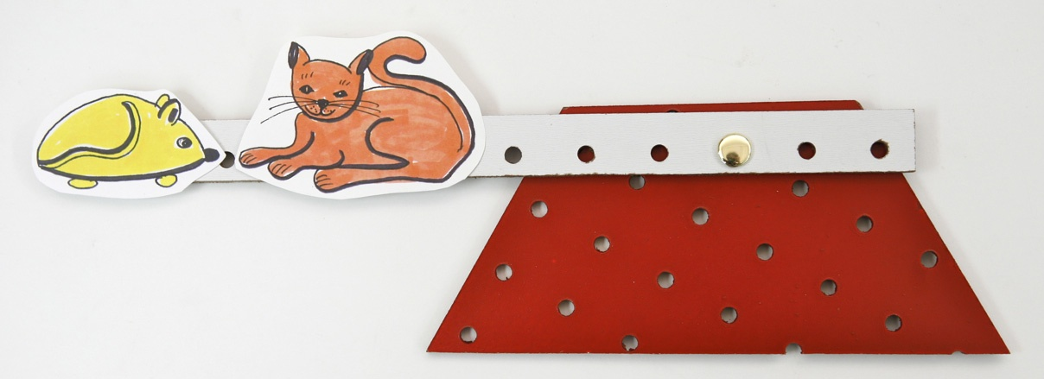
Figure 1: See-saw that lets cat and mouse go in the same direction
Distribute the see-saws students have already made that look like Figure 1.
- Do the cat and mouse go in the same or opposite directions?
Lead a discussion about different distances you can travel in the classroom, distance from home to school, distances you can walk and distances you can’t, etc. Ask two students to walk two different distances simultaneously. Which one went further? Be careful to distinguish distance from direction. Two trips could have the same distance, but be in different directions. Two trips could be in the same direction, but with different distances. If a distance is more, we say you have to go further. If it’s less, then the trip is not as far.
Then demonstrate the see-saw, showing how it moves up and down, as in Figure 2.

Figure 2: Movement of the cat and mouse
To make the difference in movement obvious, trace each path with a pencil or marker. Have someone hold the see-saw steady on chart paper, while you trace the movement first of the cat, and then of the mouse, as in Figure 3.
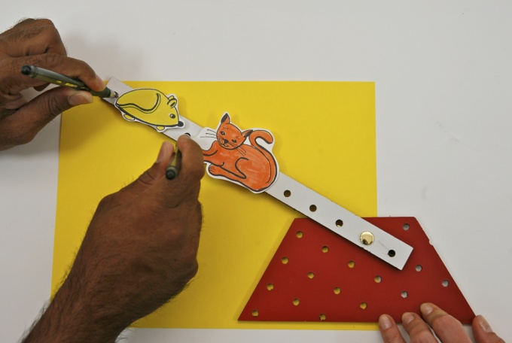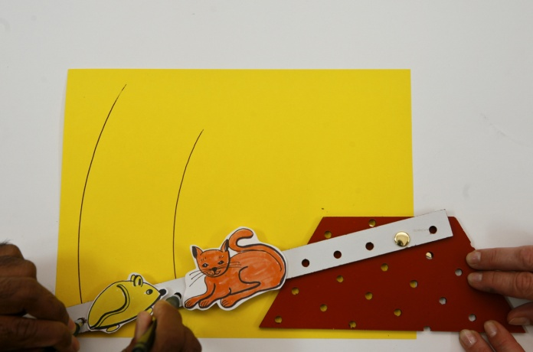
Figure 3: The path each one follows
Ask students:
- What difference do you see between how the cat moves and how the mouse moves?
- What makes one ride better than another?
- Who gets a better ride – the cat or the mouse? Why? What else do you notice about them?
- If the other one wanted the better ride, what would you have to do?
Distribute materials and challenge students to:
Make a see-saw which gives the cat a better ride (goes further) than the mouse.
See Figure 4.
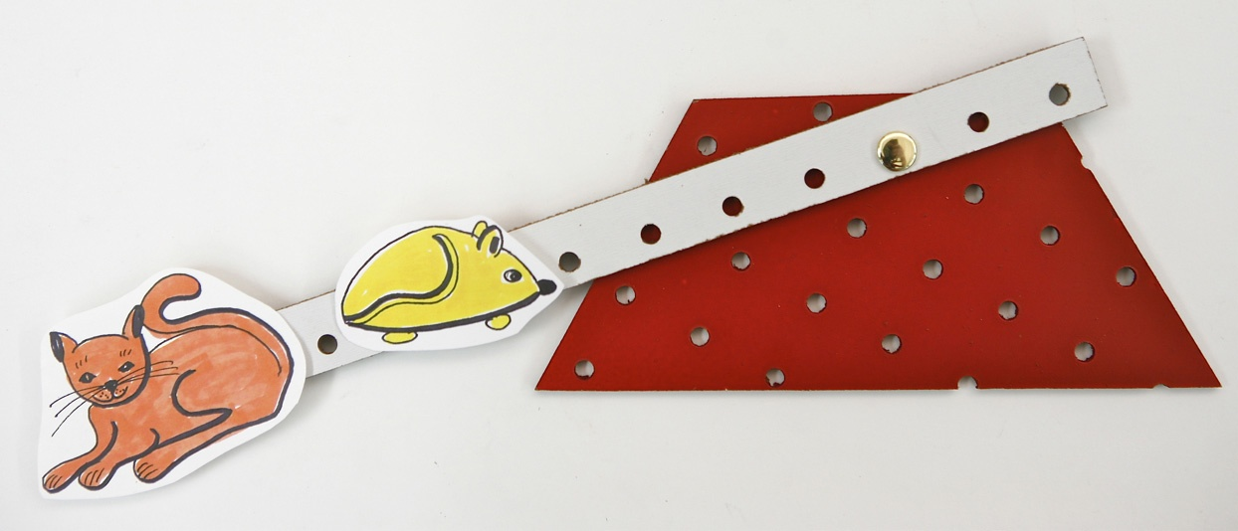
Figure 4: Now the cat gets the better ride.
3. Different distances, different directions: Review the first see-saw they made. The cat and mouse went in opposite directions. Present the following challenge to the students:
Now the cat still wants to get a better ride than the mouse, but this time in the opposite direction. Change your see-saw so this will happen.
Help them think about what you have to change to make them go opposite. Once they have placed the cat and mouse on opposite sides of the fixed pivot, ask them to find out which one goes further.
4. Controlling the distances. Then ask them to arrange the cat and mouse so the cat goes further than the other. See Figure 5.
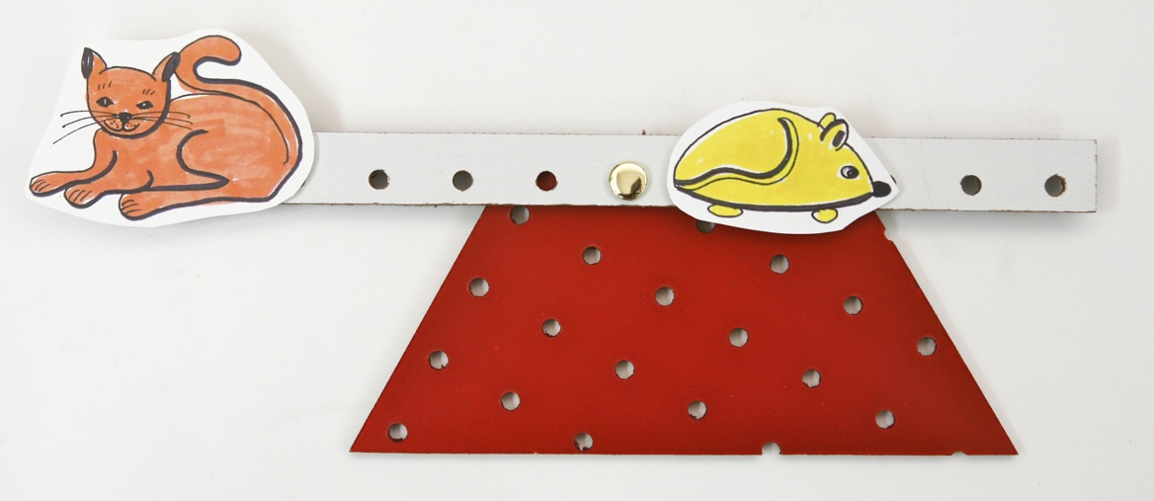
Figure 5: Cat and mouse go in opposite directions, and the cat still gets a better ride
After they have tried to solve this problem, review what they made. Test some of their see-saws to see if:
- The cat and mouse go in opposite directions; and
- The cat gets a better ride.
If students have trouble seeing who gets the better ride, test it by tracing each ride, as in Figure 3.
- Does the near one or the far one (from the fixed pivot) get a worse ride?
- If one of them wants a better ride, where do they need to be?
Word bank
Further, not as far
Worksheets
Science Notebook
- Draw a see-saw that makes the cat go further than the mouse, in the same direction.
- Draw a see-saw that makes the cat go further than the mouse, in opposite directions.

Name: ___________________________________ Date: _______________________
Who Gets the Better Ride?
Draw a see-saw that makes the cat go further than the mouse, in the same direction.
Draw a see-saw that makes the cat go further than the mouse, in opposite directions.

Lesson 9: Catching the Butterfly
Essential Question
How can we make an input control an output that moves side to side?
Task
This lesson begins with a cardboard “MechAnimation,” which uses a mechanism to make a movable net catch a stationary butterfly. The students cannot see the mechanism inside, which consists of a handle attached to a lever with a floating pivot. The lever is attached to the base by a fixed pivot, in between the floating pivot and the output (butterfly net). Students are challenged to create their own mechanism that works like this MechAnimation. To help them do so, they explore how the location of the fixed pivot – above or below the floating pivot – affects the direction of motion of the output.
Standards
CCLS – ELA:

Speaking and Listening: Presentation of knowledge and ideas
Language: Vocabulary acquisition and use
NGSS:
Science & Engineering Practices 2. Developing and using models
Cross-cutting Concepts 2. Cause and effect: mechanism and prediction; 4. Systems and system models; 5. Energy and matter: flows cycles and conservation; 6. Structure and function; 7. Stability and change
Disciplinary Core Ideas PS2: Motion and Stability: forces and interactions; ETS1: Engineering Design

Outcomes

Students should recognize that the location of the fixed pivot affects the direction of motion:

If the fixed pivot is above the floating pivot, the input and output will go in the same direction.

If the fixed pivot is below the floating pivot, the input and output will go in opposite directions.

Assessment
Objective: | Below (1) | Approaching (2) | Proficient (3)
A. Where should pivots be located to make Butterfly & net travel in the same direction? | Cannot answer | Answers but is incorrect | Answers correctly
B. Where should pivots be located to make Butterfly & net travel in opposite directions? | Cannot answer | Answers but is incorrect | Answers correctly

Materials
- Pegboard Mech-a-Blocks bases (one per student) and large strips (two per student)
- Paper fasteners
- Small amount of red and green clay or Post-Its™
- Butterfly MechAnimation (one per class) – see Figure 1
- Cutout figures of butterfly and net

Procedure
1. Demonstrate the Butterfly MechAnimation to the whole class. See Figure 1.
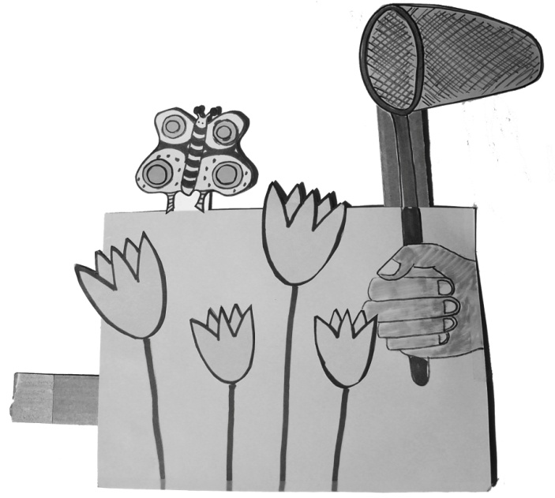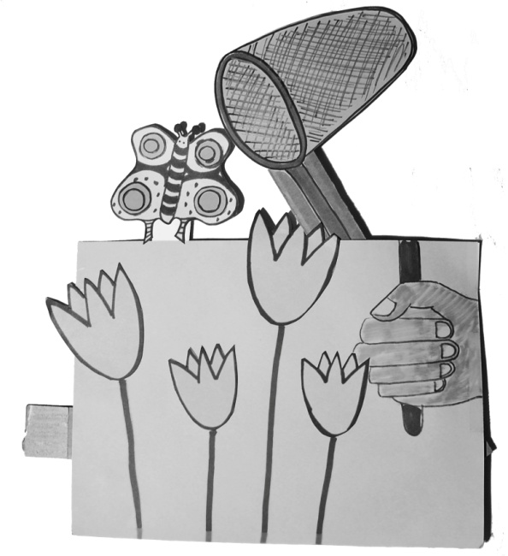
Figure 1: Butterfly MechAnimation, showing the next in the up position (left) and then about to catch the butterfly (right)
Explain that a MechAnimation uses a mechanism to tell a story. Ask:
- What story does this MechAnimation tell?
- What do I have to do to make it work?
- What happens when I do that?
- How do you think it works?
- Would you like to make your own MechAnimation?
2. What’s inside it? Review the idea of a mechanism with a separate input, from Lesson 3. The input controls the movement of the mechanism. Ask students to focus on what they can see in the MechAnimation:
- Where is the input (handle)? How do you know?
- Where is the output? How do you know?
- When the handle moves this way (to the students’ right) which way does the output go?
3. The unhappy butterfly net: Review the concept of a model. In this lesson, we’ll use pegboard models to understand our MechAnimation. Pegboard is easier to use than cardboard, so everyone will use it to make a mechanism that works like the mechanism in the MechAnimation.
Provide students with pegboard bases, strips and fasteners, and butterfly and net cutouts. Ask each student to follow the steps in making and testing this construction, as you demonstrate each one:
- Assemble two links with a floating pivot as in Figure 2. The horizontal one will become the handle, and the vertical one will become the lever. Make sure the ears of the floating pivot are pointing up towards you, so they won’t get hung up as you try to slide it along the base.
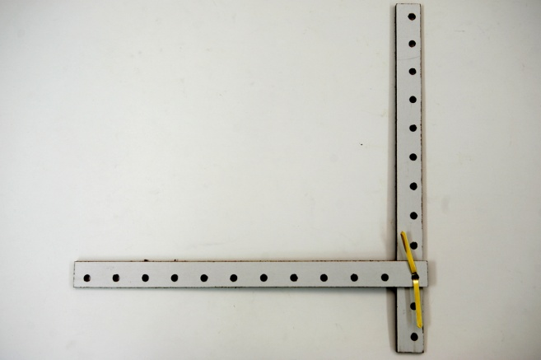
Figure 2: Two links assembled before attaching to base
- Attach the lever to a base with a fixed pivot below the handle. In Figure 3 (left) the fixed pivot is marked by an arrow. Attach the cut outs of the butterfly and net.
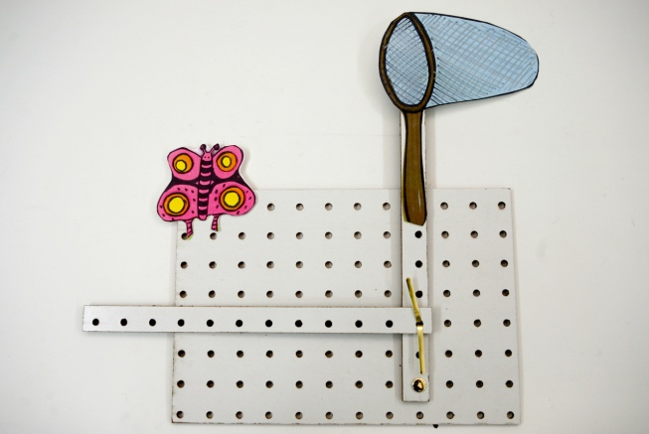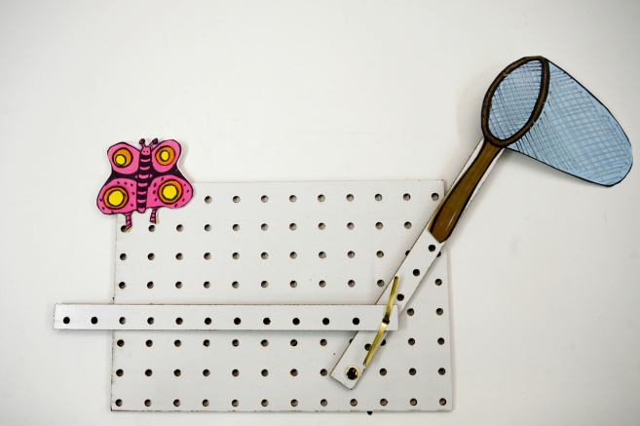
Figure 3: Unhappy Butterfly Net: the floating pivot has ears up the fixed pivot (marked by arrow) is below it
c. Push the input to the right, as in Figure 3 (right), and show the class how the net moves away from the butterfly, instead of towards it.
Students should notice that the net doesn’t catch the butterfly, because it goes to the right when you push the input in. In order to catch the butterfly, the net would have to move to the left. A good name for it might be an Unhappy Butterfly Net. Make sure that each student has made a model before proceeding to the next step.
4. Making the butterfly net happy: Challenge students to change their unhappy nets to make it possible for them to catch the butterflies:
- What happens when you use your mechanism to try to catch the butterfly?
- What would need to happen differently in order to catch the butterfly?
- How could you change it to make it work correctly?
After students have had some time to work on their models, convene the whole class to see what they have come up with. Allow students time to share their ideas, and question one another about what they have done, and how well it works. If students have not come up with a solution, provide the one shown in Figure 4:
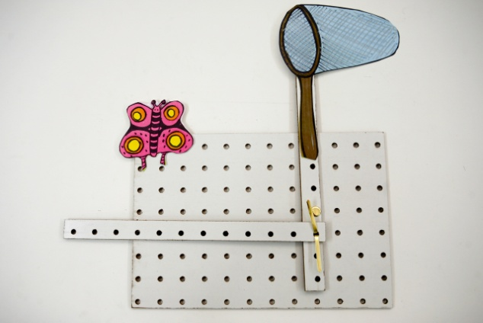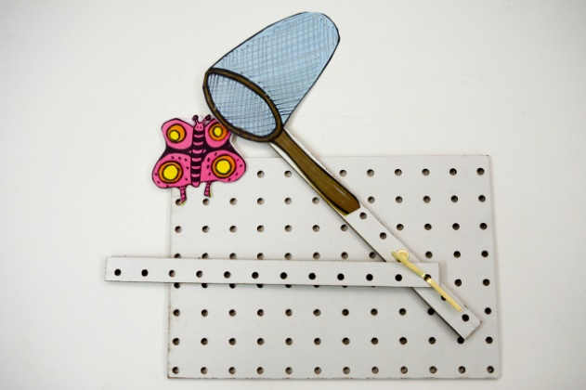
Figure 4: The Happy Butterfly Net, whose fixed pivot (marked by arrow) is above the floating pivot
In Figure 4 the fixed pivot is above the floating pivot. Push the input to the right, and let them observe how it now catches the butterfly! This model should work the same way as the original MechAnimation: pushing the input to the right makes the net go to the left.
4. Comparing models: Focus students’ attention on the differences between the two models. The second model worked but the first one didn’t:
- What is the difference between the ways the two models move?
- What is the difference between the how the two models were made?
- Why does the second one work, but the first one doesn’t?
If students have difficulty seeing the differences in construction, help them by color coding the fixed pivots and the floating pivots, so the differences are more obvious. For example, you could make the floating pivots green (for “GO”) and the fixed pivots red (for “STOP”). In Figure 5, the fixed pivots are marked by arrows, and the floating pivots’ ears are visible.
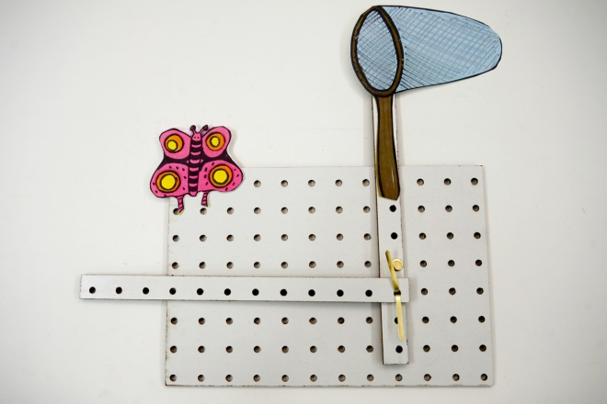
Figure 5: The Unhappy Butterfly Net (right) compared with the Happy Butterfly Net (left) using arrows to show locations of fixed pivots
Using the color code, children should notice that the only thing that’s different between the two models is the location of the fixed pivot. This location changes the way the output moves when you push the input to the right. Help them structure and remember their findings by constructing and posting a class chart, like the one in Figure 5.

Science Notebook
Show how you would make an Unhappy Butterfly Net.
What would you have to do to change it into a Happy Butterfly Net?
Key
Figure 5: Comparing the Happy and Unhappy Butterfly Nets

Lesson 10: Make your Own!
Essential Question
What issues arise when you make your own MechAnimations and how can you address them?
Task
Students use what they have learned to design and make new MechAnimations.
Standards
CCLS – ELA:

Writing: Text types and purposes; Production and distribution of writing

Speaking and Listening: Comprehension and collaboration; Presentation of knowledge and ideas
Language: Vocabulary acquisition and use
NGSS:
Science & Engineering Practices 1. Asking questions and defining problems; 3. Planning and carrying out investigations; 6. Constructing explanations and designing solutions; 8. Obtaining, evaluating and communicating information
Cross-cutting Concepts 2. Cause and effect: mechanism and prediction; 4. Systems and system models; 5. Energy and matter: flows, cycles and conservation; 6. Structure and function; 7. Stability and change
Disciplinary Core Ideas PS2: Motion and Stability: forces and interactions; ETS1: Engineering Design
Outcomes
- Each student will have completed their own MechAnimation
Assessment
Objective: | Below (1) | Approaching (2) | Proficient (3) | Advanced (4)
A. Build a MechAnimation | Nothing built | Does not work correctly | MechAnimation works as planned | (3)+ Writes a story illustrating the MechAnimation
Advance Preparation
- Collect materials that students will use to build and customize their MechAnimations

Materials
Cardstock and pegboard Mech-a-Blocks, craft materials

Procedure
1. Designing and making: Students have the opportunity to make new Mech-a-Blocks constructions, using cardstock or pegboard or both. Encourage them to use what they have learned in the past few lessons about how to control the direction of motion, and the amount an output moves.
2. Sharing: Ask each child to demonstrate what he or she has made to the entire class, and ask the class to guess what it represents.
3. Display: If possible, provide a way for student work to be available to a wider audience. Some suggestions are:
- Bulletin board or poster display: Mech-a-Blocks can be attached to poster boards or bulletin boards. By using push pins strategically – for example, at the corners – you can avoid interfering with the mechanism, allowing viewers to try them out to see how they work. Pegboard models will require the longer pushpins to keep them mounted. If students have made pictures or written descriptions, these can be posted too.
- Museum table: For visitors, including parents, staff and other children, the Mech-a-Blocks can be displayed loose on tables with signs inviting viewers to guess what they will do and then test them.
- Invention Convention: You can stage a science-fair style event, to give children an opportunity to explain what they made and how it works to parents and other visitors.
- Puppet show: You could coordinate all of the MechAnimations around a common theme, and use them for staging a class puppet show.

Glossary
Lesson 1
Base: A stationary platform to which the moving parts are attached. The base usually remains stationary while the other parts move. The large rectangular pieces are intended to serve as bases, but any relatively large piece can serve as the base.
Fastener: A small pin that connects two pieces, preventing them from pulling apart.
Pivot: A fastener that allows other parts to rotate.
Strip: A long, narrow rectangular piece.
Shape: Generic term for other pegboard pieces, besides strips and bases.
Lesson 2
Cause-and-effect: A feature of systems, in which one event makes another event happen.
Fixed fastener: A fastener that attaches another piece to the base.
Fixed pivot: A fixed fastener that allows one part to move, while the other stays still.
Floating pivot: A fastener that joins moving parts together with a
Input: The place on a mechanism that you push or pull in order to make another point move.
Mechanism: A set of attached pieces that has at least one moving part, which can move while another part (the base) stays still.
Output: The place on a mechanism where you look for movement, as a result of making the input move.
Phony fastener: A fastener that attaches to only one part, and has no mechanical function.
Structure: Something that has no moving parts, which can move only if all the parts move in the same way – by the same amount and in the same direction.
System: Something that has interrelated parts and includes an input and an output.
Lesson 3
Control: Something that determines what something else will do.
Fixed pivot: A fastener that attaches a lever to the base at one point, allowing the lever to turn but not slide away.
Floating pivot: A fastener that attaches one link to another, but not to the base.
Input controlling a lever: A link that can make a lever move in either direction because the two are attached by a floating pivot.
Lever: A rigid piece that is attached to the base at one point, allowing it to rotate but not slide.

Lesson 4
Diagram: A 2D representation that shows only the most important features of something.
Drawing: A 2D representation that shows as much information about something as possible
Symbol: A gesture, sound, mark or image that represents an idea, action or object.
Lesson 5
Cardstock: Thin cardboard that can be used to make mechanisms.
Model: Something used to represent something else, in a way that is cheaper or easier to use than the original. A model retains essential features of the original, while omitting features that are unimportant or distracting.
Pegboard: A rigid material that has holes in it.
Lesson 7
Direction: Which way something is moving
Same direction: traveling alongside each other
Opposite directions: traveling away from each other
Lesson 8
Further: more distance
Not as far: less distance

